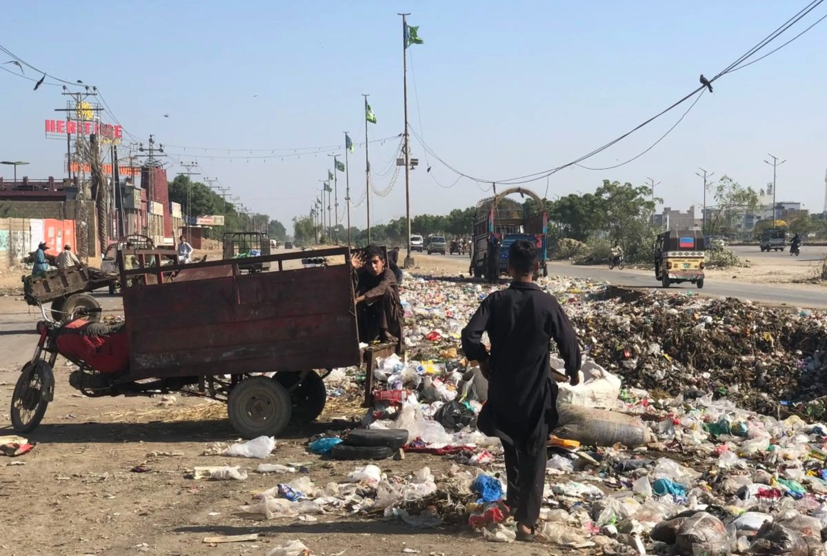

Mapping the Landscape

# Waste Pickers in Pakistan

## Challenges, Opportunities, Strategies

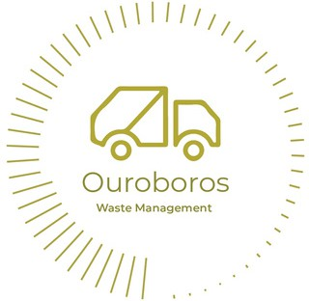

### Final Report

January 2025

Commissioned by the International Alliance of Waste Pickers and Women in Informal Employment Globalizing and Organizing (WIEGO) and Undertaken by Ouroboros Waste Management (OWM) supported by Karachi School of Business & Leadership (KSBL)

#### Summary

The study provides valuable insights into the complex landscape of waste picking in Pakistan, offering a nuanced understanding of the associated challenges, opportunities, and organizational strategies.

Recognizing the limitations and unique characteristics of waste picking in the country is essential for informing sustainable waste management policies and circular economy strategies.

Maximizing the contribution of waste pickers to the circular economy hinges on aligning these strategies with the practical realities uncovered in the research.

Acknowledging and incorporating the informal sector, as well as promoting inclusivity in action planning initiatives, government policy, and legislation, are crucial steps towards establishing and advancing circular supply chains.

#### Authors

|  |  |  |
| --- | --- | --- |
| Shiza Aslam Circular Economy Expert Karachi School of Business | **Ali Syed** Circularity Expert/ Founder Ouroboros WM | **Dr. Mansoor Ali** Waste Management Consultant Ouroboros WM |
| Shiza Aslam is a circular economy expert with over 5 years of experience in industrial ecology, assessments, and creating livelihoods from waste. With a background in Environmental Engineering and a master's degree in environment, science, and policy, she has received technical training in landfill design and management as well as lifecycle assessment.  Shiza has worked on various national and international projects focused on secondary resource management, social sustainability, life cycle assessments, public health, and economic benefits of inclusive waste management. Currently, she serves as a research head at the Circular Plastic Institute at Karachi School of Business and Leadership | Ali Syed is a circular economy and waste management expert with over 12 years of experience across Southeast Asia, South Asia, Australia, Europe. Focused on contributing to sectors in their infancy, founded Ouroboros; to serve as a bridge between the formal and informal sector.  A range of contributions to International Organizations - IFC, World Bank etc MNCs (Engro, PepsiCo, Unilever, Tetra Pak and Coca Cola) and Public Sector. With the goal of realizing holistic materials circularity through end- to-end solutions. Competencies ranging from pr-feasibilities, market assessments, materials innovation, operations, inclusivity, informality and resource management. His expertise is leveraged to support self- sustainable impact projects. | Dr. Mansoor Ali is a highly experienced waste management consultant with a focus on Asia, particularly Bangladesh and Pakistan, specializing in project planning, system design, recycling assessment, and generating livelihoods from waste, with a strong academic background and extensive work in 18 developing countries |

#### Acknowledgment

We extend our sincere gratitude to the International Alliance of Waste Pickers (IAWP) and Women in Informal Employment Globalizing and Organizing (WIEGO) for financially supporting the research on waste pickers in Pakistan. Their funding has enabled us to conduct comprehensive research, engage with waste pickers, and learn about the scale of waste pickers' organizing in Pakistan.

**A TRIBUTE TO A LIFE-LONG ENABLER**

We extend our gratitude to all contributors for their unwavering support, patience, and understanding during this challenging period.

August 31st, 2024 marks the chehlum of my father Mr. Bilal Mustafa Syed who occupies a pivotal role among mentors and advisors. His legacy inspired the creation of Ouroboros for many reasons. In particular my father, along with his best friend, were both quiet yet steadfast cheerleaders for a boy pursuing his dream, even from the background and perhaps without fully realizing it. Ouroboros began with nothing more than a piece of paper and a dream, without any evidence or track record to support it, just the determination to defy the odds.

Encouragement and unwavering faith kept me going when Ouroboros existed solely as an idea. Together, daring to dream big, fueled by nothing but a shared vision, unyielding determination, and an unshakable belief in achieving the impossible.

Twelve years ago, without formal methodologies, multi-disciplinary or breath of technical skills in the recycling space, I embarked on a journey. Living in Australia and frequently visiting Pakistan and other parts of Asia and Europe, I had an obsession to test a hypothesis: a recycling business with three core goals:

Supporting the environment, as inspired by my father

Creating job opportunities, particularly for women, as exemplified by my grandmother

Generating income, or as I call it, "as a engine lubricant to life".

This led me to jump on motorbikes and rickshaws, tracing a lead from Gujranwala, Punjab, to all five provinces of Pakistan. Over time, I explored countless streets, major scrap markets, and hidden corners, drawn by the challenges faced by those at the heart of the circular economy.

I began this journey with a group of 4-5 individuals who spoke on my behalf in various dialects—Urdu, Saraiki, Pashto, Punjabi—to help bridge the cultural divide and avoid revealing how foreign I was to my own land. Build connections, enabling us to start bridging the gap between the formal and informal sectors, driving systemic change.

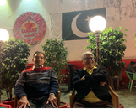Ouroboros, rooted in Pakistan or more so the Global South, symbolizes the "Renewal of Life," representing the passing of knowledge and responsibility from one generation to the next. This principle aims to:

Capture social, human, intellectual, and financial capital

Address disparities across social classes, cultures, races, religions, and beliefs

Use privilege for good, turning words or dreams into actions for others.

A core philosophy, passed down from my grandfather, is simple: "Work hard and do good."

Over time, it was the resilience of the informal sector that inspired me the most. Mapping Pakistan’s waste pickers wasn’t just about understanding their work—it became a journey of human connection. These individuals, often categorized and labeled, revealed themselves to be humans first, working tirelessly for their families and contributing to society.

For true justice and equity, breaking bread with one another is essential. "Love thy neighbor as thyself." "A society grows great when old (and young) men and women plant trees in whose shade they shall never sit."

This tribute is for all the fathers, mothers, and families who serve as lifelong enablers, paying it forward. It’s also for those who have supported the works and our team to share a glimpse of their lives over the years, and especially to my colleagues **Adeel Pervez and Shiza Aslam, who lost their fathers - Muhammad Aslam and Pervez Khan.**

Here’s to **Muizze Kamran** having lost family members throughout this period and my family friend and cousin Sadaf Habib.

In conclusion, let me leave you with the final, critical aspect not limited to the fine print above:

"You can’t choose—just face what you are given. This is called humility, my friend." — Mahjabeen Abidi Habi

**Contents**

Introduction 4

Methodology 6

Harvesting Insights: Data Collection 7

Brief description of survey cities 8

Karachi 8

Lahore 8

Muridke 9

Who are waste pickers in Pakistan? 10

Major groups and their activities 11

Types of waste pickers and definitions 13

Social Context 16

Social Background 16

Working Environment 17

Housing 19

Waste pickers Roles across the value chain 19

How do waste pickers operate along waste stages? 20

Interaction among waste-picking groups 24

How waste flows in the value chain 26

Incomes and sources of credit 26

Social protection and gender 28

Gender 28

Social protection during COVID 29

Social network and work structures 29

Navigating Collaborative Solutions 30

Trade Unions and Officially Accepted Organizations 32

Changes in waste systems and their impact on pickers operations 35

Annex: Major Themes 37

#### Introduction

The present report offers an analytical summary of findings of qualitative research on ‘waste pickers’ in Pakistan carried out from late 2022 to mid-2023.

Pakistan’s municipal solid waste management footprint stands at 28 to 38 million MT of waste per day, however, based on characterizations majority of this is organic waste. Therefore, it is important to consider the ‘parallel economy’ working in tandem, comprising of materials like paper, plastics, metal, and glass, which comprises more than 2.2 million MT of plastic that is primarily collected and recovered by waste pickers as an example [1]. With an assumption that waste pickers across the waste value chain, reclaim 13% of recyclables from MSW [2], it is estimated that it may be possible that across the country up to 200,000 to 333,334 individuals are associated with waste picking in Pakistan.

The informal sector, particularly waste pickers, play a critical role in the circular economy of low-middle- income countries, retrieving and diverting waste to recycling markets, supplying secondary material, reduce landfill and waste-to-energy reliance. Structuralist ascribes the waste pickers as the sub-ordinated unit of the economy and plays a pro-cyclical role i.e., reduced recovery and labor costs. Though, to quantify the contribution of waste pickers, to assess their role in circular Pakistan, and to study the socio-environmental vulnerability associated with waste pickers requires adequate mapping, which may be updated regularly.

**Table 1** presents a detailed case for the need for mapping by presenting a set of indicators. These indicators are typically used for policy/intervention planning (e.g., EPR), advocacy, and meeting SDG goals e.g., SDG 3, 8, 9, 11, 12, 13, 15 – to name a few. Moreover, the fifth meeting of the United Nations

1. *IFC. (2023). Pakistan Plastic Market Study: Circularity Assessment. Final Workshop (virtual)*
2. *Aslam, S., Ali, F., Batool, A., & Sheikh, Z. (2021) Application of material flow analysis for the assessment of current municipal solid waste management in Karachi, Pakistan. Waste Management & Research.*

Environmental Assembly was held In March 2022 with the aim to reach agreement to successfully reduce plastic pollution globally. It recognized “the significant contribution made by workers in informal and cooperative settings to the collecting, sorting and recycling of plastics in many countries”.

Waste pickers contribute significantly to circular economy and solid waste management. As Pakistan continues to grow economically and global trends on sustainability continue to influence national policy landscape, there is more pressure brought to essential sectors including solid waste management. However, the poor data and information on waste pickers is likely to lead the government to tackle these issues with non-inclusive models or/and inadequately responding indicators listed in Table 1, that are imperative to sustainable growth and circular economy.

**Private Sector View On Role of Waste Pickers And Strategy For Inclusivity Under Circular Economy Initiatives**

Waste management in Pakistan has gradually transformed from an orthodox and conventional municipal service to a functioning enterprise which is largely managed by the waste pickers and other actors in the informal waste value chain. It provides livelihoods to over hundreds of families with a trading high volume.

It has numerous complexes inter linkages with the public and private formal sector that require a large bulk of these services. However, these stakeholders are not represented or consulted at the time of framing vital waste management decisions.

It is integral to bring the informal waste sector into the circular economy cycle in order to properly ‘close the loop’.

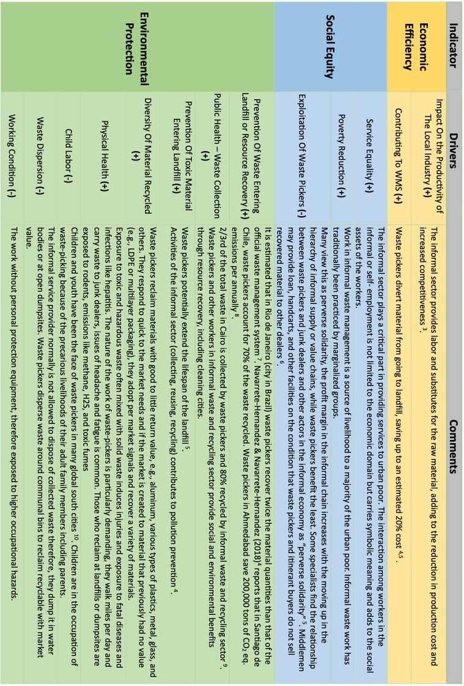

Table1: Waste pickers performance in the waste management sphere **11**

1. Navarrete-Hernandez, P., & Navarrete-Hernandez, N. (2018). Unleashing Waste-Pickers’ Potential: Supporting Recycling Cooperatives in Santiago de Chile. World Development, 101, 293–310. hOps://doi.org/10.1016/j.worlddev.2017.08.016
2. Fergutz, O., Dias, S., & Mitlin, D. (2011). Developing urban waste management in Brazil with waste picker organizations. Environment and Urbanization, 23(2), 597–608. hOps://doi.org/10.1177/0956247811418742
3. Kaza, S., Yao, L., Bhada-Tata, P., & Van Woerden, F. (2018). What a Waste 2.0: A Global Snapshot of Solid Waste Management to 2050. In What a Waste 2.0: A Global Snapshot of Solid Waste Management to 2050. The World Bank. hOps://doi.org/10.1596/978-1-4648-1329-0
4. ColeOo, D., & Bisschop, L. (2017). Waste pickers in the informal economy of the Global South: included or excluded? International Journal of Sociology and Social Policy, 37(5–6), 280–294. hOps://doi.org/10.1108/IJSSP-01- 2016-0006
5. Carvalho, M. da S., Rosa, L. P., Bufoni, A. L., & Oliveira, L. B. (2012). Puing solid household waste to sustainable use: a case study in the city of Rio de Janeiro, Brazil. Waste Management & Research, ISWA, 30(12), 1312–1319. hOps://doi.org/10.1177/0734242X12462280
6. Oates, L., Sudmant, A., Gouldson, A., & Gillard, R. (2018). Reduced waste and improved livelihoods for all : Lessons on waste management from Ahmedabad, India.
7. Fahmi, W., & SuOon, K. (2010). Cairo’s Contested Garbage: Sustainable Solid Waste Management and the Zabaleen’s Right to the City. Sustainability, 2(6), 1765–1783. hOps://doi.org/10.3390/su2061765 10 Gutberlet, J., Kain, J.-H., Nyakinya, B., Oloko, M., Zapata, P., & Zapata Campos, M. J. (2017). Bridging Weak Links of Solid Waste Management in Informal Segments. The Journal of Environment & Development, 26(1), 106–131. hMps://doi.org/10.1177/1070496516672263

11 Aslam. S. (2020). Sustainable Collaboration; Transforming Alliances for EPR in non-OECD Context. MSc thesis. Lund University, Sweden.

In the current economic downturn, the job of waste picker has taken on new importance as an employment opportunity for those with limited education and skills and is viewed as survival entrepreneurship. Moreover, waste picking is increasingly recognized as making a valuable contribution to global environmental efforts and the development of cities.

#### Methodology

This mapping study utilized WIEGO's classification of waste pickers, which includes street waste pickers, dumpsite/transfer station waste pickers, itinerant buyers, sorters, and municipal workers. However, in the context of Pakistan, waste pickers were further categorized into four broad groups, as outlined in the Table 2.

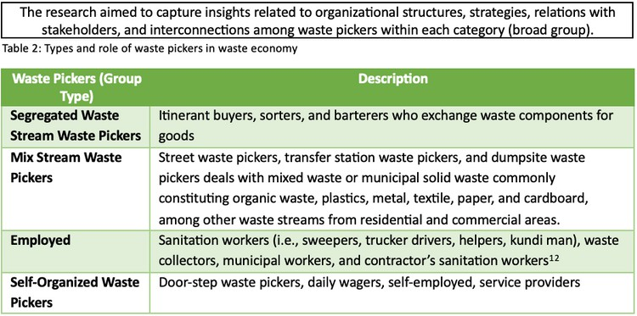

There are significant socio-economic differences between these groups, including segregated waste stream pickers, mix stream pickers, and those in between.13 Based on prior research and experience, it is

apparent that the threats and challenges faced by each group, as well as their organizational structures,

vary considerably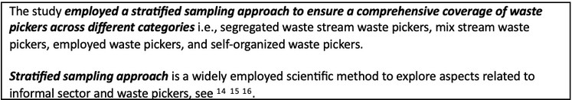.

1. Note there is no consensus on including salaried sanitation workers as waste pickers. We have discussed the conceptual challenges around defining waste pickers and the contextual landscape of Pakistan, necessitating their including in the ‘who are waste pickers in Pakistan’ section.
2. A reflection on the dynamics of some of the individual waste pickers (and groups) are captured in Ahmed. S., & Ali.

M. (2022). An overview of solid waste management systems in the city of Karachi: past and present. LSE Cities.

1. Hartmann, Chris (2017). Waste picker livelihoods and inclusive neoliberal municipal solid waste management policies: The case of the La Chureca garbage dump site in Managua, Nicaragua. Waste Management, (), S0956053X17307535–. doi:10.1016/j.wasman.2017.10.008
2. Bernache-Pérez G, Sánchez-Colón S, Garmendia AM, Dávila-Villarreal A, Sánchez-Salazar ME. Solid waste characterization study in the Guadalajara Metropolitan Zone, Mexico. Waste Management & Research. 2001;19(5):413-

424. doi:10.1177/0734242X0101900506

1. Omosimua, I.J.; OluranB, O.I.; Obindah, G.; Busayo, A. Working Conditions and Career Aspirations of Waste Pickers in Lagos State. Recycling 2021, 6, 1. hOps://doi.org/10.3390/recycling6010001

#### Harvesting Insights: Data Collection

**The study was conducted in three cities: Karachi, Lahore, and Muridke** (see map). The cities were selected based on their geographical spread and representative nature of waste-picking practices.

**The study utilized three methods to gather data:** interviews, surveys and key informant interviews.

**Interviews** aimed to provide in-depth understanding of the organizational structures and strategies employed by waste pickers. It also explored the dynamics of relationships between waste pickers and stakeholders such as local authorities, waste management companies, and junk/scrap dealers (Kabariwala). The interviews were conducted using semi-structured questionnaires to allow for flexibility in exploring diverse aspects of waste picking activities

10 interviews were conducted for each category of waste pickers, with a total sample of 40 interviews per city.

Altogether 120 interviews with waste pickers were conducted for the study.

**Surveys** aimed to gather quantitative data on various aspects such as working conditions, income levels, access to social protection, and health hazards. The surveys were designed to capture a broad range of challenges faced by waste pickers, providing a comprehensive overview of their circumstances.

10 surveys were administered in each category to map the challenges faced by waste pickers, with a total sample of 40 surveys per city.

Altogether 120 surveys were conducted for the study.

**Key Informant Interviews** included representatives from unions, NGOs, and other relevant entities. These interviews aimed to map the entities working with waste pickers, understand the potential roles they played, and identify the challenges faced by both waste pickers and these organizations. The key informant interviews provided valuable insights into the broader context of waste picker support systems and the existing barriers to their effective implementation.

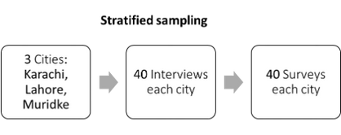

6 key informant interviews with representatives from organizations involved supporting and advocating waste pickers.

A total of 40 interviews and 40 surveys were conducted in each city (see Figure 1), ensuring a substantial sample size to complement extensive interview and survey protocols designed to capture the diversity and nuances of waste-picking activities in different urban contexts.

*Figure 1: Data Collection Protocol*

The data obtained from interviews and surveys underwent thorough analysis, utilizing both qualitative and quantitative methods. For qualitative analysis, the data was subjected to thematic coding to identify patterns and trends in the responses. This method helped in categorizing the information and revealing underlying themes and insights. On the other hand, quantitative data from surveys were subjected to descriptive statistical analysis, providing a numerical overview of the challenges faced by waste pickers in each category. This dual-method approach aimed to offer a comprehensive understanding of the challenges through both qualitative depth and quantitative breadth.

#### Brief Description of Survey Cities

#### Karachi

Karachi, the largest and most populous city in Pakistan, is strategically situated on the southern coast, playing a pivotal role as a prominent economic and industrial center. Recognized as the "City of Lights," Karachi boasts a rich tapestry of culture, a dynamic populace, and a bustling market landscape. The city's economic prowess is underscored by its diverse industrial sectors, encompassing textiles, manufacturing, finance, and services. Moreover, its strategic Port Qasim enhances its stature as a vital nexus for trade and transportation.

Despite its economic significance, Karachi grapples with multifaceted challenges arising from rapid urbanization, inadequate infrastructure, and pressing issues in waste management. With a burgeoning population exceeding 16 million people, Karachi stands as one of the world's most populous cities. The high population density in low- income areas reflect a mosaic of ethnicities and cultures that contribute to the city's vibrant identity.

In tandem with its demographic expansion, Karachi confronts a substantial waste management challenge. The city generates a staggering 12,000 to 15,000 tons of solid waste daily, posing a formidable task for the existing infrastructure and resources. The intricate issues of waste disposal, landfill management, and recycling demand strategic interventions to address the burgeoning environmental concerns.

Karachi's municipal landscape is organized around Districts and Cantonment regions, comprising a total of seven District Municipal Corporations (DMCs) with 221 Union Councils and six Cantonments, including Malir, Ibrahim Hyderi, Clifton, Manora, Faisal, and Korangi Creek. Beyond the established councils and zones, the city's expansion into the outskirts, such as Gadap town, extends into suburban goths and Dehs leading towards Hyderabad.

This expansion underscores the dynamic nature of Karachi's urban development, presenting both opportunities and challenges for effective governance and sustainable growth.

#### Lahore

Lahore, the second-largest city in Pakistan and the capital of Punjab province occupies a pivotal position in the northeastern region, standing as the cultural, historical, and artistic nucleus of the nation. Renowned for its opulent heritage, Lahore beckons with vibrant festivals, a delectable traditional cuisine, and a thriving arts and entertainment panorama. Beyond its cultural allure, Lahore functions as a vital educational and economic epicenter, hosting diverse industries encompassing textiles, manufacturing, information technology, and services.

This dynamic metropolis, pulsating with life, showcases a harmonious blend of old and new neighborhoods, a testament to its rich historical tapestry, artistic endeavors, and contemporary development initiatives.

Lahore is the second-most populous city with over 13 million residents, excluding the Cantonment and Defence Housing Authority (DHA) areas - current urban land use patterns consist of planned areas, semi-planned areas, and unplanned areas.

The Municipal Administration of Lahore, structured around nine zones and 274 union councils, encapsulates the city's governance framework. Notably, Lahore encompasses two cantonment boards (Lahore and Walton) areas, DHA, and various federal and provincial land-holding agencies, each managing urban areas within their respective jurisdictions.

In terms of waste management, Lahore contends with the substantial challenge of daily solid waste generation, estimated at around 7,000 to 9,000 tons. This issue stems from the city's struggle to cope with escalating waste volumes amid limited resources for proper disposal and recovery.

The city's sustained population growth, fueled by migration from rural regions and other parts of the country, underscores its role as a magnet for demographic shifts. Grappling with challenges associated with traffic congestion, urban sprawl, and pollution. In response, concerted efforts are underway to enhance waste management practices, introducing sustainable solutions to mitigate the environmental impact and promote a cleaner, healthier Lahore.

1. *However, some estimates show as high as 30 million of population due to urban immigrants and other factors*
2. *With a population of 11.3 million (PBS 2017) excluding the Cantonment and Defence Housing Authority (DHA) areas*

#### Muridke

Muridke, nestled in the Sheikhupura District of Punjab province, Pakistan, is positioned approximately 40 kilometers northwest of Lahore. This agrarian town is predominantly characterized by its agricultural pursuits, with a significant proportion of the populace engaged in farming and allied activities. Renowned for its fertile soil, Muridke boasts the cultivation of staple crops such as wheat, rice, and vegetables. Additionally, a modest industrial sector has taken root, focusing on textiles, manufacturing, and food processing. Recent years have witnessed urban development in Muridke, marked by the establishment of residential areas and fundamental infrastructure. Nevertheless, akin to many burgeoning towns in Pakistan, Muridke grapples with challenges stemming from limited resources, insufficient infrastructure, and restricted access to essential services.

Despite its smaller scale compared to urban giants like Karachi and Lahore, Muridke sustains an estimated population of around 142,728 people as of 2021 (Pakistan Bureau of Statistics). Predominantly semi-urban in character, the town's agrarian roots remain a primary occupation for a considerable segment of its residents. In terms of waste, Muridke, while generating relatively lower volumes at 72.8 tons of Municipal Solid Waste (MSW) per day compared to its more populous counterparts, is not exempt from the challenges associated with urban development. The waste composition is distinctive, encompassing both household waste and agricultural waste.

Notwithstanding its size, proactive efforts are underway to effectively manage and dispose of waste in Muridke. However, the town encounters challenge inherent to many smaller locales in Pakistan, including those related to infrastructure and resource limitations. As Muridke continues its developmental trajectory, a concerted focus on sustainable waste management practices will be integral to mitigating environmental impacts and fostering a resilient and harmonious urban environment.

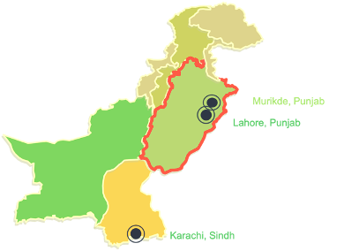

#### Who Are Waste Pickers in Pakistan?

This section defines waste pickers and provides an overview of the service provision (collection), separation, and/or sorting practices employed by various groups of waste pickers to identify and categorize recyclable items that hold market value. These collections and separation practices are already established and ongoing, and they bring livelihoods and other benefits to the groups involved. This section delves into the waste streams and how waste moves/flows throughout the value chain concerning waste picking. It is crucial to comprehend the impact of different waste-picking groups at various stages on changes in waste streams, as well as the reduction of waste and recyclable items. Such understanding is necessary to recognize the socio-economic features and obstacles encountered by these groups and assess their contributions to the waste management process.

For this study, we define **“waste pickers” as individuals who engage in separation or sorting practices to identify and categorize recyclable items with market value as a means of earning a livelihood**. These practices can be either (a) standalone, where individuals work independently to collect recyclable items from streets, communal bins, transfer stations, and dump sites, or involve the purchasing of recyclables in exchange for money or bartering for products; alternatively (b) individuals taking up waste picking as an additional source of income, in addition to their main roles in service provision, labor, or employment.

The implication here is that people of various socio-economic status are engaged in waste picking, relying on waste picking as a sole source of livelihood or a supplement to meet their basic needs. In either case, if individuals in their current status are involved in waste picking on a regular or intermittent basis, we consider them as waste pickers. As it happens, many waste pickers switch in and out of waste picking depending on their socio-economic circumstances and low barriers to entry in many cases.

###### Defining Waste Pickers: Conceptual Challenges and Income Variability in Pakistan

Defining waste pickers solely based on their primary income factor poses conceptual challenges. It is arguable that individuals should be classified as waste pickers only if their income from retrieved and sold recyclables exceeds their monthly salaries, labor, or service provision i.e., primarily relying on waste picking. However, with the exception of some types of workers, we do not have data on the proportion of collection and picking incomes. For municipal-employed sanitation workers and salaried contractors, the salaried income is known to surpass the picking income. On the other hand, transfer stations pickers, landfill/disposal site pickers, and street pickers rely mainly on picking income as they lack a fixed salary. While there exist various categories of sanitation workers and pickers where the income proportions, such as monthly salary, private collection income, self-employed collection income, and income from material retrieval, remain uncertain. It is crucial to acknowledge that waste pickers and sanitation workers in many countries tend to have multiple incomes, variable incomes and other forms of resources. This is particularly true for Pakistan. Therefore, for this report we have not bounded the waste picker’s identity to income factor alone.

To illustrate, consider the case of waste pickers as service providers. Waste pickers as service providers, similar to salaried or contracted waste pickers [19] have two streams of income: a) from their service provision i.e., fee from households or contractual body (e.g., union or housing society); and b) reclaiming and selling recyclables. It could be argued that waste pickers as service providers shouldn’t be recognized solely as waste pickers but with self-identity or term that would be more reflective of their work or occupation. We stand with referring them as waste pickers since it is observed that they opt not to provide services in some of the low income areas, where households may be able to provide low service fee of 50rs (0.18 $) however, since the waste composition of such areas has hardly any reclaimable material left that it doesn’t make economic sense for them to serve as service providers only – indicating that reclaiming waste is a critical component of their business model and operations as waste pickers.

1. *Salaried or contracted waste pickers have monthly salary or daily wage for their services or labor.*

#### Major Groups and Their Activities

Recyclable waste materials are often separated either at the source or during transport for disposal, involving various groups performing different activities. These practices create employment opportunities and additional income for many individuals. The quantity, composition, and characteristics of waste change as a have implications for the official waste management system. Some of these activities are carried out outside the municipal waste management system, driven by the market demand for recyclable materials and in some areas, there may be overlap between these activities. Figure 3 and Table 3 summarize the nature of the picking activities across different stages of waste value chain

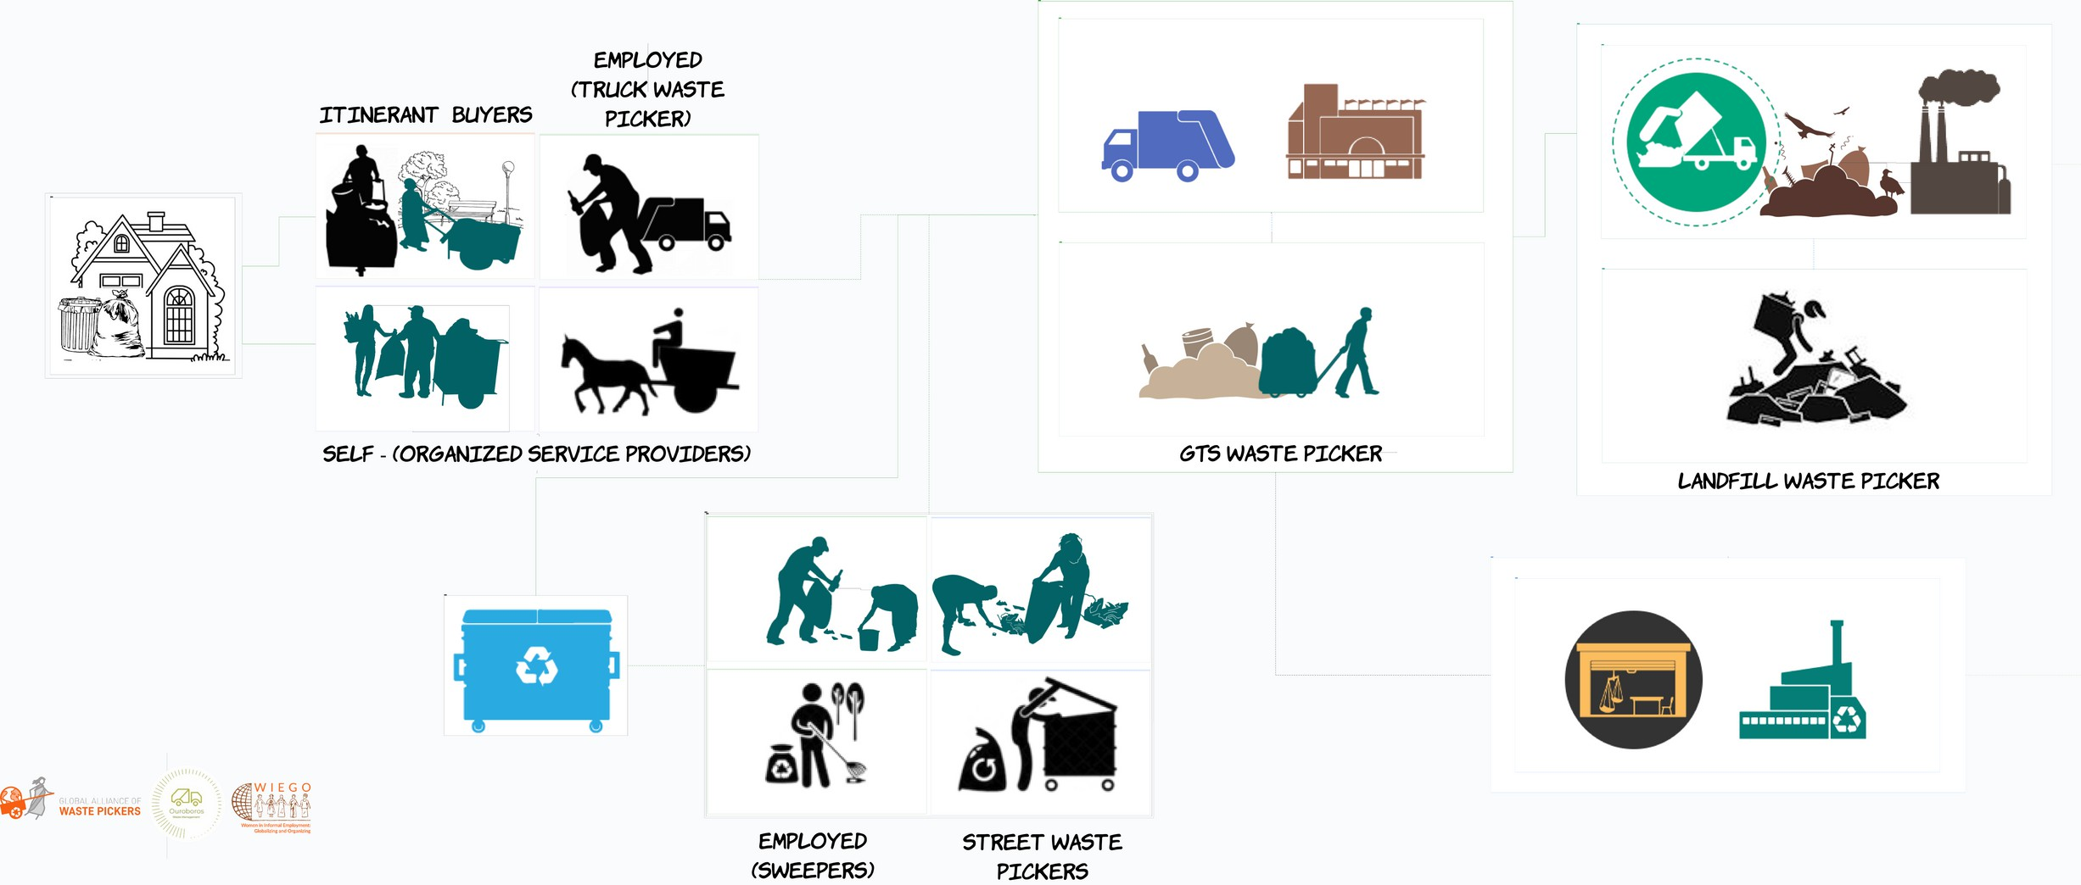

*}*

#### Types of waste pickers and definitions

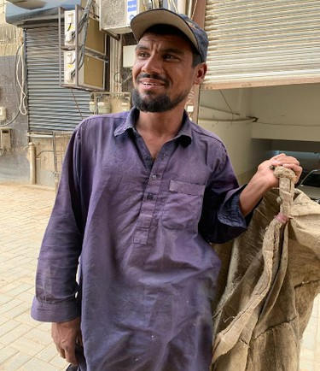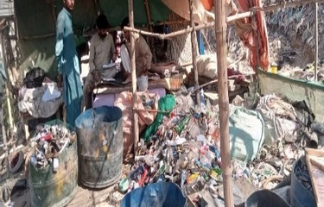**Street Waste Picker:** A street waste picker refers to an individual (some also work as group) who engages in the collection of recyclable materials and usable objects directly from the streets and public spaces. These individuals often navigate the streets on foot or with simple equipment, such as a cycle, carts or bags, to gather items of value. They tend to move around and not necessarily settle in certain areas. Street waste pickers typically operate independently and may interact with residents or businesses to acquire their discarded materials. They often sell the collected items to recycling centers or intermediaries for further processing or resale.

**Transfer station waste pickers:** A transfer station waste picker is an individual who works at a waste transfer station [21] or katchra kundi [22]. They may stay at one location (stationary) or move around to cover other stations. These waste pickers are responsible for sorting through the incoming waste at the transfer station to identify and retrieve recyclable materials or salvageable items. They play a vital role in diverting reusable and recyclable materials from the waste stream, contributing to the reduction of landfill waste and promoting resource recovery.

1. *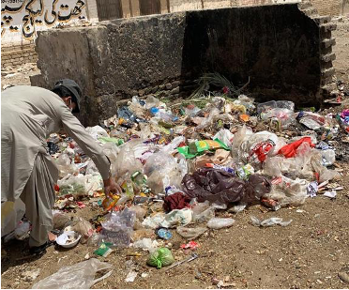serves as an intermediate collection point for waste before it is transported to a landfill or recycling facility*
2. *The term "katchra kundi" refers to a community-based storage area where household waste is collected at the secondary level. It serves as a relatively larger communal bin, where residents in a neighborhood deposit their waste for further handling and disposal.*

**Landfill waste pickers:** A landfill waste picker is a person who engages in the collection and retrieval of discarded materials from landfill sites. These individuals work within landfill areas, picking through the deposited waste to identify and salvage items that can be reused, recycled, or sold. They are typically stationary (staying at one location) however, in secondary or smaller cities, some may visit other areas. Landfill waste pickers often operate in challenging conditions, searching for valuable materials amidst piles of waste. Their efforts help reduce the volume of waste that ends up in landfills and contribute to the recovery of resources from discarded items.

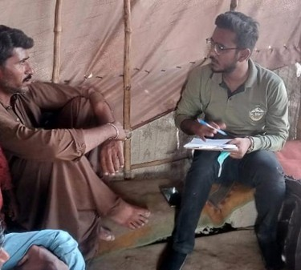

**Waste Picker as Collection Service Provider:** A waste picker as a collection service provider is an individual who operates as an independent contractor or entrepreneur in the waste management sector. They offer collection services to households, businesses, or institutions for waste collection and retrieval of recyclable materials or waste.

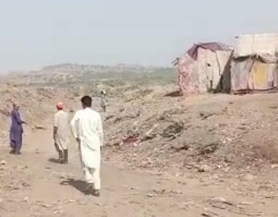

They may act as stationery i.e., bound to specific areas for their activities. These waste pickers establish their own routes and schedules, often using their vehicles or carts to collect and transport the materials. They may work directly with clients, charging fees for their services, and contribute to the efficient and organized collection of waste within their designated areas. They usually sort waste on- site or on the go and sell reclaimed material to the junk dealers.

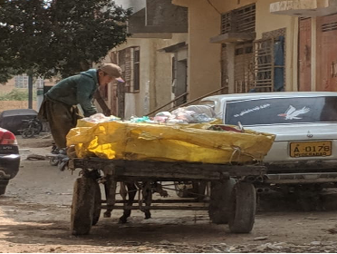**Waste Pickers as Daily Wager:** Self-employed waste pickers as daily wagers are individuals who are engaged by a waste management company or organization in waste management (waste vehicle driver, helper, collector) or sanitation activities (sweeping) on a day-to-day basis, often without formal employment contracts or long-term commitments. These waste pickers work independently, relying on their skills and strength since most activities are physically demanding, such as emptying bins, sweeping for hours under the sun. They typically collect waste items in supplement to their primary assignment due to insufficient minimum daily wage. The earnings from waste picking are based on the quantity and quality of the materials they gather, which fluctuates depending on the daily market rates and their level of effort to reclaim items in addition to the daily employment.

**Permanent Contracted Waste Picker:** A permanent contracted waste picker is an individual who is employed by a waste management company or organization under a formal, long-term contract. These waste pickers work regularly and consistently, following a set schedule and performing waste collection or sweeping tasks as part of their job responsibilities.

They may act as stationery i.e., bound to specific areas for their activities. They may receive benefits, such as a fixed salary, social security, and access to training or support programs provided by their employer. They typically collect waste items as a supplement to their primary job.

Permanent contracted waste pickers contribute to the stable and organized operation of waste management systems. Many of such workers are also referred to as public service providers or sanitation workers.

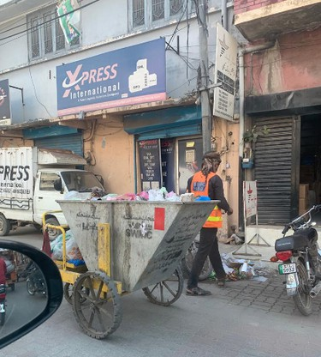

**Contracted/Salaried Waste Pickers as Temporary Worker:** Contracted/salaried waste pickers as temporary workers are individuals who are engaged in waste picking activities for a specific duration or project on a contractual or salaried basis. They are hired by waste management companies, municipalities, or organizations to assist with waste collection, sweeping, or related tasks during peak periods, special events, or specific projects. These temporary workers may receive a fixed salary or hourly wage for the duration of their contract and contribute to maintaining the efficiency and effectiveness of waste management operations during temporary surges in demand. Typically collect waste items as a supplement to their primary job.

**Barter:** A barter is an individual or entity that engages in the exchange of goods or services without the use of money. In the context of waste picking, a barter refers to a waste picker who trades or exchanges collected recyclable materials for other items of value. Instead of selling the recyclables for cash, the waste picker negotiates with potential recipients and agrees to receive alternative goods, such as food, clothing, household items, or other commodities, in exchange for the materials.

They tend to move around and not necessarily settle in certain areas. Bartering allows waste pickers to meet their immediate needs or acquire essential resources without relying on traditional monetary transactions.

**Itinerant Buyer (waste-picker):** An itinerant buyer, also known as a roaming buyer or mobile collector, is an individual who travels to different locations, such as streets, neighborhoods, or communities, to purchase separate recyclable materials directly from waste generators. They tend to move around and not necessarily settle in certain areas. These buyers typically have specialized knowledge of the recycling market and the value of different materials. They carry weighing scales, tools, and cash to assess, weigh, and purchase the recyclables from sellers on the spot. Itinerant buyers may focus on specific types of materials, such as paper, bottles, or scrap metal, and they offer competitive prices based on market rates. By engaging directly with waste generators, itinerant buyers facilitate the collection and diversion of recyclables while providing an immediate source of income for sellers.

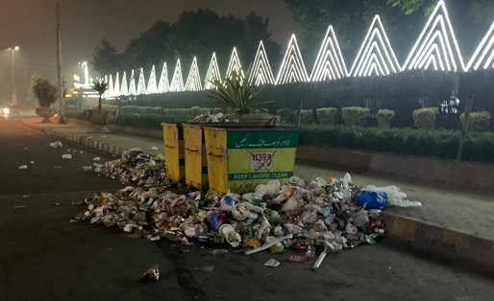

#### Social Background, Working Conditions and Housing

#### Social Background

The waste picking industry in Pakistan is characterized by the presence of family, relationships, and self-employment. While some individuals have been engaged in waste picking for generations, others turn to this occupation out of necessity when they are unable to find employment elsewhere, migrate or to cope with economic shocks.

Waste picking is attractive due to its low barriers to entry and the potential source of income.

It is a preferred option for marginalized groups, individuals with limited education, and minorities. Additionally, during economic downturns, COVID and inflation as seen during fiscal years of 2021- 2023, even those workers who do not typically fall into these categories have turned to waste picking when faced with unemployment.

***“I used to be a gardener but got laid off from my job and there is no other job for me.***

***Therefore, picking waste”***

(Street Waste Pickers)

***“I used to work as a Laborer before this (carrying tiles and cement)”***

(Self-employed as daily wager, waste picker)

Individuals who become waste pickers often start as street pickers, as there are no territorial or other types of controls in place. Many transfer station waste pickers come from families with a history of waste picking, as it may help in negotiating access to waste. Waste pickers as collection service providers are typically self-employed or own account workers, mostly in this business either because of (a) the economic/business sense of the waste picking and waste collection service provision (b) family business, and (c) outsourcing i.e., running a business under commission or contract –

***“I used to work as a plumber but then sensed economic feasibility in this activity.***

***I started this work (waste collection) three years ago, initially, I would observe the people in this field (waste pickers) and talk to them then started my own business.***

***I am the first among the family doing this business”***

Municipal permanent employees often secure waste picking jobs through political connections, family quota or ties. Personal connections and networks play an important role in the recruitment of salaried waste pickers in the given context. Municipal permanent employees don’t actively seek the occupation of waste-picking as they largely rely on it for additional income as mentioned earlier.

Waste picking to them is primarily to seek additional income. Since they have sanitation work as their primary job which may get hectic therefore, permanent employers tend to sell reclaimed material as mixed recyclables i.e., plastic, paper, and metal all mixed (instead of sorting to individual waste type) and sell as mixed material by weight to Kabariwala. Segregated waste stream waste pickers tend to be in and out of the profession based on economic opportunities, with many having previously worked as itinerant vendors –

***“I used to sell fried crackers for two years, then worked as a tailor and would embroidery on women's clothes for 6 months.***

***I have been working as a waste picker for less than 2 years now”***

Family involvement in the waste picking industry has a significant impact on the entry, recruitment, and retention of waste pickers (see figure 4).

Existing family connections and networks within industry tend to influence and facilitate the transition of new entrants into waste picking professions. This influence can be seen in the high number of waste pickers who come from families with a history of involvement in industry, among all categories of waste pickers.

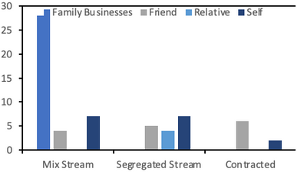

*Figure 4: Point of influence and introduction of individuals to waste picking profession*

#### Working conditions

The working conditions and challenges faced by waste pickers highlight the significant issues and challenges that this sector faces. Across different categories of waste pickers, such as waste pickers as service providers, permanent contracted waste pickers, daily wage laborers, and transfer station and landfill waste pickers, there are a multitude of challenges that threaten the health, safety, and livelihood of waste pickers.

One of the most significant challenges that waste pickers face is the chronic challenge of harassment and security issues. Waste pickers may face harassment or intimidation from law enforcement authorities, including the police.

Due to the informal nature of their work and the perception that waste pickers are engaging in unauthorized activities, they may be subjected to unjustified scrutiny, fines, or even confiscation of their collected materials –

***“Police often accused me of having stolen material and called off as thieves”***

(Transfer Waste Picker)

**Waste pickers frequently reported negative experiences and relations with police** in general – “Police can randomly stop my rickshaw and ask for money” (waste picker as a service provider). Pushto speaking Waste pickers [23] in particular seemed to have a bitter relationship with police, “If there's a fight or argument, the police would take us to the station and charge us. Even if someone comes in between to settle the case/issue, they also get in trouble” another, *“They stop us and ask for money. Although I was born and raised here, since I am Pushtun, they bother us. Nobody supports us because the police can get them in trouble too. So only our relatives come to our help”*. Some even reported humiliating experiences, “They often shave our heads as a punishment”.

Waste pickers often face social stigmatization and negative stereotypes associated with their occupation. They may be viewed as troublemakers, drug addicts, thieves, or as individuals involved in illegal or unsavory activities. This negative perception can result in marginalization, discrimination, and limited opportunities for waste pickers to improve their livelihoods or access support services –

***“Usually ignore the people even if they abuse as we poor people can’t afford any fight or these situations”***

(Street Waste Picker)

The nature of waste picking work itself is also a significant challenge for waste pickers, as they are frequently exposed to a range of diseases and are at risk of injury due to the lack of protective equipment (*see Figure 5*).

***Landfill waste pickers*** are exposed to stagnant water that breeds diseases and face the risk of injury due to the lack of safety equipment.

Waste pickers have to take care of their own protection. The absence of safety measures or support in case of accidents or emergencies further exacerbates the challenges of waste picking work.

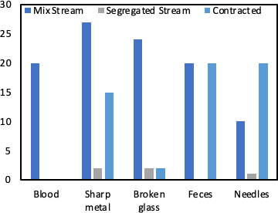

*Figure 5: Working conditions: Exposure to hazardous/precautionary waste items*

***Waste pickers (contracted and daily wagers)*** in private and public companies, waste pickers have to deal with high workloads, insufficient staff, and no paid time off.

1. *exact identities have not been disclosed due to potential risks*

Permanent contracted waste pickers are subject to extreme workloads, and the number of workers is often insufficient. Daily wage laborers may not receive any breaks or face pay deductions if they take a break.

Additionally, ***contracted and salaried waste pickers*** often do not receive paid leave and may be subject to restrictions imposed by their supervisors. Contracted/salaried and daily wage face physical strain due to nonstop working and high workload – “We only get water breaks and sometimes we do not get a break at all, and it hurts my arms”. They are not given paid leave, are not provided with Personal Protective Equipment, and face issues with faulty equipment. Improving working conditions and providing adequate support to waste pickers is necessary to address these challenges and promote their health and well-being.

There are also issues with the equipment provided for waste pickers, with some bins and trolleys being faulty and posing a risk of injury. The lack of proper equipment and infrastructure makes it challenging for waste pickers to carry out their work safely and efficiently. Wherein, the fluctuating prices and low profit margins for waste pickers is a major across among all categories and groups of waste. Table 4 shows the selling price of different reclaimed waste items for waste pickers during the month of May- June 2023.

Problematic weather is yet another pronounced issue faced by waste pickers, which over the years has become more intense. High temperatures during the summer months can significantly reduce the working hours and earnings of street waste pickers, leading to increased vulnerability to poverty shocks. They also lack access to shelter and drinking water, making the job even harder - “During the summers, the heat decreases our working so it's very difficult to work under these conditions. After one round we searched for water.

However, since street waste pickers are not bound by work hour limitations, therefore they may take breaks or choose not to pick up waste at the expense of earning. Nonetheless, waste pickers find it a hard job, more difficult in challenging weather conditions, “It is very hard to live there, especially during rainy seasons or extreme weathers”. Additionally, flooding caused by heavy rain or overflow of sewage channels during monsoon season can make working conditions hazardous and pose a significant risk to the health and safety of waste pickers.

***Transfer station and landfill waste pickers*** tend to pick waste despite the flooding and other hazards during natural disasters – “We do face difficulties in harsh seasons, but we do not have a choice but to work. It is better to work in the summer because there is generally more waste in summer than winter e.g., there are more plastic bottles”.

Waste pickers who provide collection services face challenges during floods (e.g., limited or no access to households), which reduce their income.

*Table 4: Market Rates for recovered materials available Waste Pickers (Pkr per kg) by Waste Type*

|  |  |
| --- | --- |
| **Type of Waste** | **Market Rate for Waste Pickers (Pkr per kg)** |
| Paper Cardboard | 12-26 |
| Metal | 180-320 |
| Steel | 100-130 |
| Plastic (PET, HDPE,PE, PP) | 35-70 |
| Used Beverage carton (UBC) / Tetra pack | 12 |
| Multi-layer packaging MLP(chip wraps, etc.) | 2 |

Overall, the challenges faced by waste pickers are numerous and significant. These issues threaten the health, safety, and livelihoods of waste pickers and their families, and highlight the need for action and support from both the government and the private sector to improve the working conditions and well-being of waste pickers.

#### a) Mix Stream b) Segregated Waste Stream

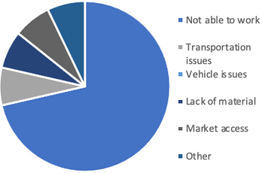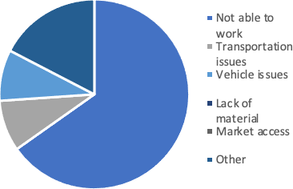

*Figure 6: Impact of flood/rain on a) mixed waste stream waste pickers and b) segregated stream waste picker*

#### Housing

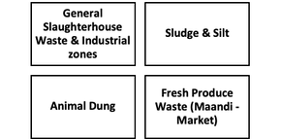

**Municipal Solid Waste (MSW) Profile**

MSW, in addition to the residential waste, caters to a few other waste streams (see figure below) that are collected and disposed at landfill by municipalities and its subcontractors.

However, due to lack of compliance and enforcement, it is common to have hazardous waste streams (e-waste, medical waste) mixed with MSW at secondary collection points and dumping areas – exposing waste pickers to considerable risks.

Note, in principle, such waste streams (e.g., e-waste, medical waste) are not covered under the definition of MSW per the legislation.

Due to the lack of affordable housing options, waste pickers often resort to setting up informal settlements near landfills or other waste disposal sites - “Our houses are flooded when the water in the naali [24] overflows, and we just sleep here because we cannot do anything about it”. These settlements are often at risk of eviction by the authorities, which can lead to displacement and loss of livelihood for the waste pickers. The housing situation for waste pickers is often precarious and inadequate, with street waste pickers facing the constant threat of eviction and relocation of their makeshift dwellings.

Even waste collection companies and police can ask them to remove their ‘jhuggis’ [25] - “Even the waste collection companies and police tell us to remove our jhuggis”. In landfill areas, waste pickers face additional challenges due to the lack of basic infrastructure such as gas and electricity - “After monsoon, the water accumulates for 2-3 months, and it spreads a lot of diseases” (landfill waste picker).

Moreover, waste pickers across different categories often lack access to basic amenities such as clean water and proper sanitation facilities. For instance, some segregated waste stream waste pickers have to rely on collecting water from mosques to take a shower after collecting waste to prevent the spread of diseases.

1. a type of drainage system
2. "Jhuggis" is a term used in Pakistan to refer to temporary structures made of bamboo, plastic sheets, and other materials, which are often used as housing by people with low-income and limited resources. These structures are often located in informal settlements or on the streets and are often subject to eviction or demolition by authorities.

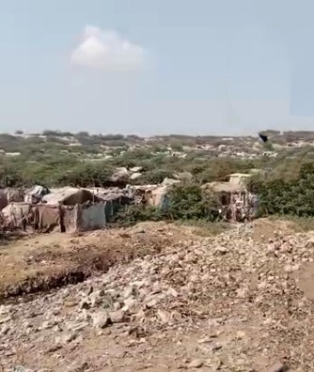

#### How do waste pickers operate along waste stages?

Street waste pickers have a great deal of flexibility when it comes to setting boundaries and choosing areas and streets to opt for waste picking. There is no definite trend in selecting an area or setting the frequency to visit particular streets. Instead, it is mostly subject to the availability of waste. Waste pickers often say, "I collect waste from different locations every day, depending on how much waste I find. I decide it myself." Another waste picker said, "There are no boundaries. We can go anywhere we want. If we get enough materials from a site, we don't go to other areas. Otherwise, we go to other areas".

In some cases, the familiarity of the area, particularly with the locals, influences the decision of waste pickers to choose areas for waste picking. For instance, a waste picker stated, "People in these areas are familiar with me. So, there is no difficulty in any regard. If I went to other areas, people are bothered sometimes and ask us to run from here".

In areas where waste collection services are inadequate or non-existent, street pickers are more welcomed and perhaps presented with

opportunities to expand waste picking as an entrepreneurial service. Waste pickers become service providers and offer their services to the residents who are willing to pay for waste collection. As a result, waste pickers are able to expand their operations and increase their income.

Once waste material is reclaimed, most of the street waste pickers sell it to junk dealers on a daily basis. However, storing waste and selling it in bulk allows waste pickers to have a higher profit margin. Unfortunately, street waste pickers lie at the bottom of the poverty pyramid and can't afford to store waste since they live on day-to-day earnings. Waste pickers who manage to have some savings tend to store and sell their waste every few days. One waste picker said, "I usually sell it on a daily basis but sometimes I store them for 2-3 days".

It was observed that the market sense and value of the reclaimed material are acquired over time, where new entrants (new to waste picking) learn which items to pick by observing fellow waste pickers and sharing information among themselves. In cases where waste pickers have a good relationship with Kabariwala or have been reclaiming good quantities of waste, they are advised and guided by kabariwala, further.

Waste pickers take advice from kabariwala since they consider him as their leader. It is interesting to note the dissemination of information, particularly the recovery of products (e.g., bottles, shoes) are maintained and leveraged in the waste value chain. A waste picker said, "I pick cardboard, bottles, and rubber slippers. Kabariwala tells us to bring this stuff, and then I sell it to him.

***Transfer station waste pickers*** [26] collect waste from the transfer station and segregate it, mainly bottles, caps, etc. Many sell it on a daily basis since they do not have enough space to store waste for a week, and they need money for daily expenses. However, some accumulate it for a few days before selling it to ask for a better price. Those who have some savings and space to store tend to do so.

The fact that family members are also involved in the same job indicates the limited opportunities and lack of alternative employment options in the area for most waste pickers (General Transfer Station, Open dumpsite (uncontrolled ‘landfill’, and Service Providers).

Waste pickers whose family members are also in this business may sell waste collectively for better prices. In cases where collected waste is of substantial quantity, the junk dealer may send a vehicle to facilitate the transportation of waste. Junk dealers provide vehicles while waste pickers bear the fuel cost.

In the case of **landfill waste pickers**, their work often involves retrieving materials through final disposal sites to collect recyclable materials. Landfill waste pickers tend to have a strong familiarity with the area they work in, as they often live nearby and have developed relationships with the local community. They collect waste based on their own sense of the market and the Kabariwala (scrap dealer) does not give them any specific instructions. They set their own boundaries for areas to pick waste from and sometimes go to other nearby places to collect more waste. However, due to a lack of access to public transportation and the high cost of fuel, waste pickers are limited to working in the areas near their homes.

Despite the low rates, they prefer to sell waste to junk dealers from their community or vicinity, instead of going to the main city due to the potential difficulties involved. Moreover, landfill waste pickers also face competition from other groups, such as Pushto speaking waste pickers, who take out useful waste before it reaches the waste pickers. This competition has reduced the amount of waste available to waste pickers and has thus reduced their income.

***Waste pickers as waste collection service providers*** are predominantly Pashtun (one of the many ethnic groups in Pakistan), particularly in Karachi, mainly due to their strong presence, networks and work ethics. Waste pickers as collection service providers take calculated risks and enter a competitive and often marginalized industry.

Overcoming numerous challenges and setbacks, such as building a customer base and managing finances, the waste picker is able to establish themselves gradually but steadily in the field.

This experience underscores the significance of determination and self-reliance, particularly within the realm of entrepreneurship, and self-employment. Moreover, it highlights the potential for success and self-sufficiency within marginalized communities, including waste pickers, given the appropriate opportunities and support. They also provide services to private housing societies and residencies under union (sub-component of municipality), in the absence of formal and public solid waste management services.

Under this modality, waste pickers receive a monthly lump sum for their services either from the union or administration, while taking ownership of the waste and earning supplementary income from sorting recyclables.

In terms of recruitment, **waste pickers as collection service providers** tend to be cautious in hiring new individuals, particularly due to their unfamiliarity with the work, especially when they are young. New recruits are given a short probationary period of 1-2 days to demonstrate their ability to work effectively.

If an individual is unable to meet the expected standards during this period, they are asked to leave the job. This practice ensures that only those who can perform their duties effectively are retained within industry.

1. *Here transfer stations mean formal stations, communal bins and open spaces used for storage.*

***Segregated waste stream waste pickers*** operate at the initial stage of waste generation and typically interact directly with households, shopkeepers, or security guards to purchase waste. They negotiate prices based on a price list provided by the junk dealer and may establish customer relationships for regular waste collection.

Segregated waste stream waste pickers operate within walking distance from their dealers, who purchase waste. Though, they do not have a designated route or fixed area for waste collection and often adjust their routine based on the behavior and routine of the residents (such as generation patterns), as well as other factors such as religious festivals.

In contrast, ***permanently contracted waste pickers***, who work as sanitation workers, bring the reclaimed waste to a designated transfer site where they sell it to junk dealers. They are usually paid based on a fixed rate for mixed waste and may sometimes separate the waste themselves. These waste pickers may establish relationships with specific junk dealers for financial assistance and sell to those who offer a good price.

However, not all sanitation workers engage in waste picking, and it depends on the employing company, supervisor, and economic situation.

**Contracted waste pickers (permanent and temporary)** and **daily wager** may work as sanitation workers or helpers on waste vehicle and bring the reclaimed waste to the Kabariwala, while waste collectors may take the reclaimed material to a transfer site where they may separate the waste or sometimes sell it on the route.

Junk dealers come to the transfer station to purchase the waste, and waste pickers only sell to those who offer them a good price or may establish a relationship with one dealer, usually based on financial assistance.

**Salaried waste pickers** usually sell recyclables as mixed waste and are paid based on a fixed weight rate (PKR per kg of mixed weight) instead of individual items such as plastic or cardboard. This means that their pay remains the same regardless of market rates for the waste.

However, not all sanitation workers pick waste, as it depends on the employing company, supervisor, and economic situation.

In most cases, sweeping and other sanitation-related tasks are hectic, and many sanitation workers do not bother separating or collecting recyclable waste.

However, difficult economic situations may move them to pick waste now and then, as a sanitation worker stated, "I never used to pick anything from the roads earlier, but now I do since everything is so expensive".

Overall, waste pickers operate in various capacities within the waste management system, and their work helps reduce the amount of waste that ends up in landfills.

Despite the challenges they face, waste pickers continue to play a vital role in the waste management process and provide a valuable service to their communities.

**Different Types of Waste Pickers and their Characteristics**

**Street Waste Pickers:**

Street waste pickers have the flexibility to choose their areas of operation and frequency of visits, depending on the availability of waste.

Familiarity with the area and the locals can influence their decision to pick waste from certain areas.

In areas with inadequate waste collection services, street waste pickers may be welcomed and presented with opportunities to expand their occupation of waste picking, sorting and sale

Once waste material is reclaimed, most street waste pickers sell it to junk dealers daily, as they cannot afford to store it.

Market sense and value of the reclaimed material are acquired over time, and new entrants learn from observing and sharing information with other waste pickers.

Waste pickers with good relationships with kabariwala may be advised and guided by them.

**Transfer Station Waste Pickers:**

Waste pickers collect waste from the transfer station and segregate it, mainly bottles, caps.

Many sell it on a daily basis as they do not have enough space to store waste for a week, and they need money for daily expenses.

Some accumulate waste for a few days before selling it to ask for a better price. Family members are also involved in the same job, indicating the limited opportunities and lack of alternative employment options in the area for most waste pickers.

Waste pickers whose family members are also in this business may sell waste collectively for better prices, or the head of the family will sell it on behalf of the family

Junk dealers may provide vehicles for transportation of waste when waste of substantial quantity is collected.

**Landfill Waste Pickers:**

Familiarity with the area is important for landfill waste pickers, who set their own boundaries for areas to pick waste from. They collect recyclables from the landfill daily and sell waste to junk dealers from their community or vicinity, despite the low rates, due to the potential difficulties involved in going to the main city.

Most landfill waste pickers' families also work in this business, and they have a basic knowledge of the area and people.

**Waste Pickers as Waste Collection Service Providers:**

Waste pickers as service providers are predominantly Pushto speaking waste pickers in the studied cities [27].

They expand their business by acquiring a vehicle for waste collection, which is usually a slow payment process based on installment. Waste pickers as collection service providers are very entrepreneurial and mostly in this business either (a) due to the economic/business sense of the waste picking and service provision, (b) as a family business, or (c) running the business under commission or contract.

**Self-Employed Waste Pickers as Daily Wager:**

Self-employed waste pickers who work as daily wagers usually work alone or in small groups and are not affiliated with any organization.

They collect waste daily and sell it to middlemen who further sell it to recycling industries.

They are generally paid on a per-kilogram basis and their income depends on the quantity and quality of waste collected.

These waste pickers often face challenges such as low pay, lack of job security, and poor working conditions.

**Permanent Contracted Waste Picker, or sanitation worker:**

Permanent contracted waste pickers are directly employed by municipalities or private waste management companies.

1. With the evolving urban landscape and rapid development of Karachi, traditional waste pickers are facing new challenges that demand a higher level of physical fitness and agility, preferable to the Pushto Afghanis. For instance, the difficult terrain of low- income settlements and the dense multi-story living structures in middle and lower-middle-income areas make it arduous for waste pickers to access every household. This has unfortunately led to the engagement of Pushto Afghan children or underage groups in the waste management system.

They have job security and receive a fixed salary along with benefits such as health insurance, paid leave, and retirement plans. These waste pickers work in teams and have designated areas for waste collection.

They undergo training on safety, waste segregation, and use of protective equipment.

**Contracted/Salaried Waste Pickers as Temporary Worker:**

Contracted or salaried waste pickers are employed on a temporary basis and are paid a fixed salary.

They work for a specific period or project and are usually hired by municipalities or private waste management companies. These waste pickers are trained on safety, waste segregation, and use of protective equipment but they may not receive benefits like permanent contracted waste pickers.

They may face job insecurity and financial instability due to the temporary nature of their employment

**Segregated waste Stream Waste Pickers:**

Segregated waste stream waste pickers are waste pickers who collect recyclable waste that is segregated from the source.

They work in partnerships with households, commercial establishments, and industries to collect recyclable waste separately.

These waste pickers generally receive higher prices for the recyclable waste they collect, as they are of higher quality and requires less sorting.

They may also receive additional income by selling compost made from organic waste. Segregated waste stream waste pickers help in reducing the burden on landfills and contribute towards a more sustainable waste management system.

#### Interaction among waste picking groups

Waste picking is a territorial activity, and street waste pickers often face restrictions in their access to waste and areas due to waste pickers as service providers who manage the waste in those areas. Waste management companies are critical of waste pickers as their work can reduce the amount of waste collected, which goes against the key performance indicators set for waste management tenders.

**Street waste pickers** may also see each other as competitors, particularly when it comes to the types of waste they collect. However, they often sell their waste to the same junk dealer who serves as their primary source of information, settlement of conflicts, and loan provider. The power relationship between scrap dealers and waste-pickers offers an interesting insight to the power dynamics.

**Transfer station waste pickers** work in a unique

environment where a handful of waste pickers work in proximity, engaging/interacting with various kabariwalas. This offers them peer-to-peer learning opportunities and collective experience that allows them to avoid being exploited, but conflicts and fights are common among waste collectors at transfer stations.

**Landfill waste pickers** have good relationships with their fellow workers but face restrictions in accessing work in certain areas due to the presence of other waste pickers who manage the waste in those areas. They see Pushto speaking waste pickers as a major concern and reason for their low income.

**Waste pickers who provide collection services** typically have designated houses from which they collect waste and receive payment. If another individual collects waste from one of their designated houses, conflict or physical altercations may arise.

**Salaried waste pickers work** as a team assigned to areas, which allows them to have a good relationship with their fellow workers, share information, and help each other out when needed. Waste-pickers at times compete with domestic workers who reclaim or retrieve some of the materials worth the value from their employer's household and supplement their income from the retrieved materials.

**Waste pickers as service providers,** particularly waste pickers, often do not allow employed waste pickers to segregate or pick anything from the waste, which can result in conflicts. Waste pickers have a positive relationship with the people they sell waste to, and they see themselves as workers for those people.



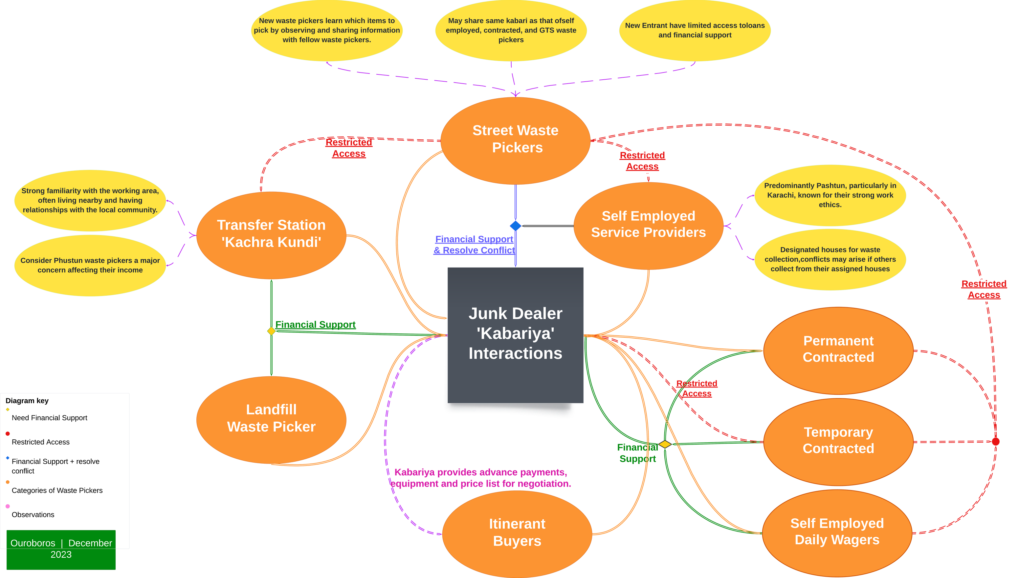

Figure 7: Waste pickers groups interaction and role of Kabariwala in the landscape

#### How waste flows in the value chain

The waste access hierarchy begins with self- organized waste service providers, itinerant buyers, and employed truck waste pickers. These groups have the initial access to waste. Generally, they are able to access better quality waste with less contamination for being close to source point and sorting on route.

Next in line for waste access are street waste pickers and employed sanitation workers. They both have access to the same spaces, such as communal bins, streets, and parks. This leads to competition between them. Street waste pickers, who rely on waste picking as their primary source of income, often have more control over these spaces compared to employed sanitation workers, for whom waste picking is a supplementary income.

As a result, conflicts may arise between street waste pickers and sanitation workers over access to waste. Following them are general transfer stations or "kachara kundi" waste pickers. They have a moderate level of access to waste as they operate at transfer stations where waste is brought in before disposal.

Lastly, landfill waste pickers have the least access to recyclable waste. They pick through landfill sites and primarily extract bones and metals. The bones are then sold in the market to extract oil and bone charcoal. Other groups of waste pickers have typically already picked recyclables, so landfill waste pickers are left with limited opportunities to find valuable waste materials.

Incomes and sources of credit

Street waste pickers often rely on loans from Kabariwala for emergency situations or when in need of financial assistance, which is usually based on verbal assurances and not for a defined period of time.

Ethnicity-based relations also play a role in establishing trust between waste pickers and junk dealers. However, new waste pickers may not be catered to for financial matters such as loans or advance payments. While loan amounts are usually small and paid back through a portion of daily materials money, they are often not sufficient for longer-term needs.

Transfer waste pickers mainly rely on loans from kabariwalas, which are provided based on verbal agreements and trust. Loans are primarily for emergencies or urgent needs, and the amount is usually small, ranging from a couple of thousand rupees. The repayment is made by deducting a portion of the money earned by waste pickers daily.

Some waste pickers prefer not to take loans from kabariwalas due to the strict repayment conditions. Landfill waste pickers in Pakistan rely on informal lending arrangements and community support for financial assistance. They receive loans from the kabariwala, who they have long-standing relationships with, and repay them in small portions until the loan is covered. In some cases, they rely on the Wadera [28] for financial support and return the loan by working as laborers.

Self-employed Waste pickers mainly rely on the kabariwala for financial assistance, and they only approach them in case of significant events or emergencies.

Once waste material is reclaimed, most of the street waste pickers sell it to Kabariwala on a daily basis. Though storing waste and selling in bulk allows waste pickers to have higher profit margin.

1. *Wadera refers to an influential feudal landowner in Pakistan who holds political and social power in their community*

This is because street waste pickers lie at the bottom of the waste service and value chain pyramid, who live on day-to-day earnings and can’t afford to store waste. Some waste pickers, who manage to have some savings (allowing them to cover a couple of days of expenses), tend to store and sell “I usually sell it on a daily basis but sometimes I store them for 2-3 days”.

Salaried waste pickers usually sell recyclables as mixed waste and, hence, are paid based on a fixed rate (instead of individual items e.g., plastic, cardboard). This means that the pay remains the same regardless of the market rates for the waste. This is a typical practice among junk dealers if they receive mixed waste.

Table 5 provides a clear overview of the known income proportions for different types of sanitation workers and pickers, while also highlighting the category where income proportions are uncertain [29].

For instance, in Karachi, there is a significant presence of self-employed Pushto-speaking waste pickers groups comprising approximately 45% of the workforce [30]. These groups charge monthly fees ranging from Rs 200 to Rs 300 per household. However, the exact breakdown of income from waste retrieval (reclaiming and selling recyclables) versus collection charges for these groups is unknown.

For salaried municipal and contractor sweepers, the income from retrieved materials tends to be relatively low. Conversely, for itinerant waste buyers, street pickers, and disposal site pickers, there is no salaried income, and their main source of income comes from waste picking activities.

Regarding self-employed waste sweepers and similar categories, the proportion of income from different sources remains unclear.

*Table 5: Market Rates for Waste Pickers (Pkr per kg) by Waste Type*

|  |  |  |
| --- | --- | --- |
| **Waste Picker Type** | **Salaried or Service Income Proportion** | **Retrieval Income Proportion** |
| Waste Picker as Service Provider | Unknown | Unknown |
| Municipal Employed Sanitation Worker | High | Low |
| Temporary Employed Sanitation Worker | High | Low |
| Itinerant Buyer | Low | High |
| Street Waste Pickers | Low | High |
| Daily Wager Sanitary Worker (Unknown) | Unknown | Unknown |
| Transfer Station Pickers | Low | High |
| Landfill or Disposal Site Pickers | Low | High |

1. *The past work on waste pickers in Dhaka un-pack this under a livelihood framework;* [*https://repository.lboro.ac.uk/articles/book/Waste_pickers_in_Dhaka_Using_the_sustainable_livelihoods_approachKey_findings_and_f*](https://repository.lboro.ac.uk/articles/book/Waste_pickers_in_Dhaka_Using_the_sustainable_livelihoods_approach_-_Key_findings_and_field_notes/9585224)[*ield_notes/9585224*](https://repository.lboro.ac.uk/articles/book/Waste_pickers_in_Dhaka_Using_the_sustainable_livelihoods_approach_-_Key_findings_and_field_notes/9585224)
2. *Exact identities have not been disclosed due to potential risks*

#### Social Protection and Gender

Waste pickers in Pakistan primarily rely on the support of the Kabariwala for loans and financial aid that pays for health, (education of children) and other expenses at home such as death of a close family member, marriage, and other important social needs of individuals.

These loans are often given without any documentation or collateral, and the Kabariwala may cut a small portion of the waste picker's earnings until the loan is paid back. Waste pickers may also receive financial support from friends, family, and even locals in the communities where they collect waste.

In some cases, waste pickers may receive financial aid from their employers in emergency situations. However, waste pickers generally do not have access to any formal social protection mechanisms, including health insurance, which can lead to financial strain when dealing with unexpected expenses.

In some cases, waste pickers may also receive financial aid from the company they work for. However, this appears to be rare and is dependent on the company. It is not a standardized benefit, and companies do not provide health benefits or insurance to their employees.

Furthermore, the waste pickers' social support network may be limited, and they may struggle to cover unexpected expenses. The lack of health benefits can also discourage employees from seeking medical attention when needed, which can lead to more serious health problems in the future.

Waste pickers generally are not noticed to be familiar with formal government schemes that provide income support or health cards. However, some waste pickers may have access to the Benazir income support scheme (government run social support program for the poor).

Waste pickers are responsible for their own health problems and medical expenses, and they are not aware of any free treatments or facilities provided by the government. The lack of social protection mechanisms disproportionately affects women waste pickers, who may have additional caregiving responsibilities and may not have access to resources or support networks to cover their expenses.

#### Gender

Despite being a male-dominated profession, women are also involved in waste picking. However, their participation in this profession is limited, and they often face societal barriers. In some families, women do not work as waste pickers but sort the collected materials, such as plastic and other recyclables, which may be in yards or homes. In contrast, some communities, such as the Kohli community at Jam Chakro Landfill (Karachi), have women who are actively involved in waste picking.

Women waste-pickers’ participation in waste collection service is limited, and they are not usually seen working in this profession. However, in some cases, women may help sort the waste at home if the waste picker brings the waste home for sorting. Additionally, if a waste picker is sick, they may take young girls from their family to help collect waste from households.

In contrast, women are more likely to work as permanent contracted sanitation workers/ waste pickers. In this case, they collect recyclable waste from the households where they work as domestic workers, which can make their duties more challenging. Some women also work as daily wage laborers in the informal waste and recycling sector, as sorters.

It is essential to note that women waste pickers face many challenges, such as lack of safety measures, low pay, and societal barriers. However, their participation in this profession is critical for their economic empowerment, and they play an important role in waste management.

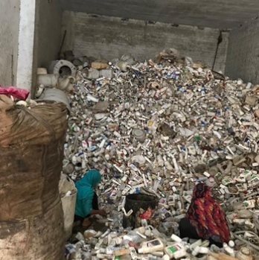

*Figure 8: Ouroboros (WM) - Informal Sector Market Identification – HDPE/LDPE Packaging*

#### Social Protection During COVID

During the COVID-19 pandemic, various forms of support were provided to waste pickers, but their reach and effectiveness were limited.

Street waste pickers received some support in the form of COVID-19 allowance and basic groceries, but most were unaware of the COVID-19 precautions beyond wearing masks.

Further research is needed to explore if waste pickers were included in COVID-19 allowance or relief fund schemes, as some waste pickers reported not receiving any support during the pandemic. Similarly, waste pickers as service providers were not aware of any vaccination programs or support, and many waste pickers as daily wagers had no knowledge of COVID-19 precautions and did not receive any assistance during the pandemic. Some of them had to resort to selling balloons and henna or borrowing money to survive during the COVID-19 lockdown.

While some government support was provided to landfill waste pickers in the form of basic groceries, segregated waste stream waste pickers did not receive any relief or allowance during the pandemic.

#### Social network and work structures

Social networks, work structures, and non-written agreements are key features of the informal waste sector in Pakistan, particularly in urban areas. Waste pickers, who often belong to marginalized communities, have developed their own system of organizing and operating within their communities, without the need for formal contracts or written agreements. This system is often based on trust, relationships, and mutual understanding.

**Waste pickers’ ability to self-organize and operate within their own communities** also helps to reduce transportation costs and increase efficiency. For example, by selling waste to local junk dealers, waste pickers can avoid the cost of transporting their waste to other locations with potentially higher prices. They can also work more efficiently by setting their own schedules and routes based on their knowledge of the local area.

**Segregated waste stream waste pickers are observed to have some bargaining and negotiation power** and may switch to another Kabariwala if offered a higher rate.

However, the loan agreements between Kabariwala and waste pickers are often verbal and not documented, leading some waste pickers to feel vulnerable in their relationship with Kabariwala. Collective selling of waste by family members can lead to better prices, and in cases of substantial quantities of waste, junk dealers may provide vehicles for transportation while waste pickers bear the fuel costs.

It is also worth noting that **waste picking is often a family business**, with many waste pickers working alongside their family members. This may be due to the limited opportunities and lack of alternative employment options in the area for most waste pickers. Working together as a family can help to increase efficiency, reduce transportation costs, and increase their bargaining power with junk dealers.

Finally, waste pickers who work as waste collection service providers are often entrepreneurial and business minded. They may invest in acquiring a vehicle for waste collection and operate under commission or contract with other businesses. For some, waste picking may be a steppingstone to other entrepreneurial ventures, and they may use their experience and knowledge gained in waste picking to start other businesses or ventures.

###### Self-organization and non-written agreements, grouping, access, ethnicity, territories, etc.

Street Waste Pickers enjoy a level of flexibility in their work, with the ability to set boundaries and choose which areas and streets to collect waste from. There is no clear trend in how often they visit certain areas, with the decision mostly based on the availability of waste.

In some cases, familiarity with an area or its residents may influence their choice of location. Street waste pickers often fill gaps in waste collection services in areas where they are inadequate or non-existent, presenting opportunities for them to expand their services as waste collection providers. Once waste is collected, most street waste pickers sell it to junk dealers on a daily basis, although some may store waste and sell it in bulk to increase their profit margins. The value of reclaimed materials and the market sense for them is acquired over time, with new entrants often learning by observing and sharing information with fellow waste pickers. Those with good relationships with Kabariwala, the middlemen who buy and sell waste, may receive advice and guidance from them. The recovery of certain products, such as bottles and shoes, is maintained and leveraged in the waste value chain.

**The waste pickers as service providers may provide waste collection services under contract or commission, either initially established by themselves or hired/partnered by others to run their business.** Waste pickers designate their own areas or territories for waste collection, based on a 'first come, first serve' principle. They face fewer challenges in their work due to their familiarity with the local community. However, the importance placed on religious or ethnic factors in recruitment and business expansion decisions is an area of concern. New individuals are not given significant amounts of work initially, and a short probationary period of 1-2 days is given to demonstrate their ability to work effectively.

Waste pickers may work alone or take someone along when there is a high workload, such as a young boy (9-14 years age) ringing the doorbell and asking for waste. Rates for waste collection services are typically fixed for everyone, with some waste pickers charging on a per-bucket basis while others may charge a fixed monthly rate.

**Segregated waste stream waste pickers exhibit self-organization and rely on non-written agreements to coordinate their activities**. They use equipment provided by Kabariwala, including a weighing machine and thaela (cart), and negotiate prices for waste with customers using price lists provided by the junk dealer.

Waste pickers establish customer relations and may visit specific areas with set intervals, while some itinerant buyers switch to alternative livelihood options during Ramadan. However, unlike other waste picker groups, segregated waste stream waste pickers do not have designated streets or areas for waste picking, and their activities are based on day-to-day transactions.

Access to higher-quality waste in societies can result in better rates for rehri walas (small carts are called rehri in local language) (iterant buyer), who need to obtain gate passes to enter these areas, which may be influenced by factors such as ethnicity and personal connections.

The buying rates for certain types of waste may also be affected by factors such as weight and level of effort required for sorting, resulting in deductions from the total weight.

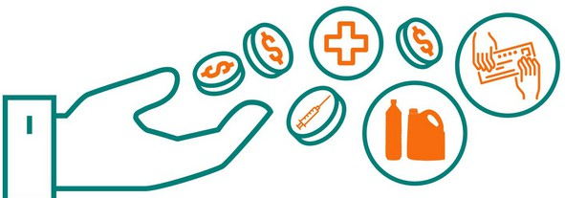Overall, segregated waste stream waste pickers exhibit a unique approach to waste picking, based on adaptability, customer relations, and a reliance on daily transactions rather than bulk storage and sale of waste.

#### Navigating Collaborative Solutions

Within this dynamic landscape, our exploration of the involvement of *kabariwalas* (junk dealers) in the issues faced by waste-pickers and conflict management reveals important insights. We recognize that the relationship between waste-pickers and *kabariwalas* is often patronage-based and can be exploitative at times. However, they also play an important social role in the operations of waste pickers amidst the absence of critical amenities and support from governments, changes in the waste streams and practices, the political nature of waste management, and exclusive urban development.

Overall, stressing that the upper-level exploitation (instances and impact) is more. In considering the broader perspective, it is important to recognize that the issues related to waste pickers’ exploitation extend beyond the activities of individual Kabariwala. The impact and extent of exploitation reach beyond their actions alone.

If the conflict cannot be resolved, junk dealers may become involved. In some cases, **junk dealers may serve as mediators between waste pickers and other collectors** to help resolve conflicts and ensure that the waste pickers are able to continue their work.

Organizing around Kabariwala is crucial for waste pickers, as these individuals serve as mediators, leaders, and sources of information in the waste value chain. Kabariwala may also become involved in resolving conflicts, but the relationship between waste pickers and Kabariwala is often more personal and supportive.

Street waste pickers often sell their waste to the same junk dealer, and this relationship is reinforced by the fact that junk dealers serve as the primary means of (a) acquiring loans for waste pickers; (b) helping settle conflicts and fights “in these circumstances (fight etc.) I usually go to Kabariwala. as they are with us in our thick and thin” another, “There is no union, but we consult with each other if there is a problem or anything worse happened to us. The Kabariwala is usually our leader”, and c) junk dealers serve key sources of information (e.g., material prices, products worth reclaiming) – “Kabariwala is our leader, and we usually took advice from them”.

**Segregated waste stream waste pickers receive daily payments** or advance (moori’) from junk dealers to purchase waste from customers and only sell their collected waste to their designated Kabadiwala. In cases where customers sell waste more than money (moori) them have with them, they would inform junk dealers to send them money. The junk dealer then sends them the money and sends another rehri wala or cart to transport the waste to the shop. Or in cases, when waste pickers are unable to decide or set price, waste pickers call the junk dealer and discuss with him the negotiations, waste

pickers usually await junk dealers’ approval. The weight of certain products may be deducted when they buy the waste, and they may offer a lower rate for mixed waste that requires greater effort to sort – “if I buy an old cycle, the weight of the tires is deducted, and customers are paid only for the remaining weight. The Kabariwala does the same with us”. Segregated waste stream pickers sell certain products to others, e.g. selling heavy items in the market instead of junk dealers for better prices.

**Landfill waste pickers often sell their waste to junk dealers** from their community or vicinity, despite lower rates, due to potential difficulties (e.g., transport cost) involved in going to the main city - “I sell waste on a daily basis, because the rates are less in our area, and the places that offer a good price are far away”. At transfer sites, waste pickers may separate waste, and junk dealers come to purchase waste. Waste pickers only sell to those who offer a good price or may establish ongoing relationships with particular junk dealers.

**Kabari, or scrap dealers, are often perceived as a nuisance in urban areas** undergoing recent development, particularly with the emergence of high-rise buildings. Their presence is often viewed as unattractive and incompatible with the modern aesthetics and landscape of these urban environments. It is important to integrate contextually appropriate waste management considerations into the planning and design stages of urban development projects.

Overall, **organizing around Kabariwala is critical for waste pickers to navigate the complexities of the waste value chain,** negotiate fair prices, and access essential resources and support. However, the informal nature of these relationships can also leave waste pickers vulnerable to exploitation and instability. Therefore, efforts to formalize and regulate these relationships may be necessary to ensure a more equitable and sustainable waste management system.

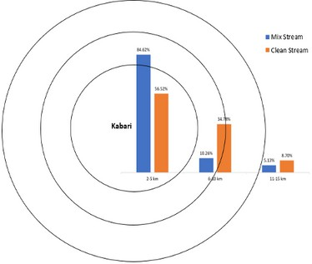

*Figure 9: Average distance waste pickers travel to sell reclaimed material - indicative of spatial boundary around waste pickers and Kabariwala*

#### Trade Unions and Officially Accepted Organizations

In Pakistan, very few organizations engage in any capacity with waste pickers. Municipalities and authorities tend to have either tolerant/ignorant or ‘stick’ (penalizing) attitudes towards waste pickers. This mainly espouses existing laws and by laws that do not favor waste pickers and a lack of framework allowing formal-waste pickers integration or cooperation.

Under ***City District Government (CDG) and the Services and Assets Management Agreement (SAMA)*** municipal service provisions are typically managed by CDG or municipalities. However, certain areas, such as (a) cantonment board; (b) defense housing authority; (c) cooperative housing societies;’ (d) private housing societies/schemes; (e) Pakistan railways or federal agencies areas; (f) Service delivery began), follow a "self-help, self- finance, mutual aid, and self-governance" model for solid waste management (SWM).

In these cases, SWM services are managed by the societies themselves or through private waste management companies, with municipalities responsible for end disposal. This creates opportunities for waste pickers (particularly service providers) to cater for the basic service gap. In many cases, it serves as a barrier since such areas are mostly gates with restricted or no entry to waste pickers ***(see section below for details).***

**Currently, there is no framework in place that serves as a guide for municipalities or CDG to build the waste management services incorporation with waste pickers.** This often leads to clashes and fights between municipal staff and waste pickers. For instance, in Karachi, a low-middle income area (named ‘Model Colony’) had been catered by waste pickers as service providers in the absence of an official or formal waste management system.

The Sindh Solid Waste Management Board (SSWMB) is now responsible for MSWM in Karachi under its service provision plan, extending the MSWM service in Model Colony without taking waste pickers in confidence or building upon their existing structure. The issue remains unresolved with both SSWMB and waste pickers attempting to provide the same services to the same residents. Perhaps the International Labor Organization (ILO) [31] and similar organizations can play a role in developing a framework of work and cooperation.

The **contractual implications in waste management contracts** are subject to power dynamics, for instance, changes in power systems, relationships with authorities (such as commissioners and counselors), and the nature of the contract (formal or informal). These factors influence decisions regarding contract allocation or extension, often necessitating negotiations and considerations to facilitate the contracting process and for waste pickers to cater areas for service provision.

1. *ILO has recently carried ‘Rapid assessment relating to child labour in garbage picking’ the publication will soon be public. ILO is now working to run a pilot for waste pickers (in planning phase).*

The **role of unions (trade and labor) has been limited** and in fact being sidelined. Traditional trade unions have experienced a decline in both their membership and financial stability and have struggled to adapt to the evolving requirements of the country's workforce. This workforce comprises of young individuals engaged in informal and contractual employment, who are exposed to contemporary issues and perspectives. However, despite their exposure to modern trends, these workers may still face challenges related to education and skills.

During the interviews with waste pickers, only one union (Shaheen Union) are reported to be of help in some capacity to waste pickers. Nonetheless, some waste pickers voiced for the need of union, “should give us loan for business and help us when we were accused of buying theft material by police”.

The non-profit sector is also engaged in very limited capacities with waste pickers, except for Aabroo Foundation, Akhtar Hameed Khan Memorial Trust, and Gul Bahao (in no particular order) who have been working under different modalities with waste pickers.

**Case of Aabroo Foundation**

In the case of Aabroo Foundation, the journey of waste picking among children unfolded against a backdrop of challenging circumstances. Established in 2013, Aabroo Foundation, a charity organization, recognized the dire need to support underprivileged children by facilitating them with education, trainings, and meals.

Within the organization's efforts to provide education and a brighter future for these children, they collaborated with Friends of Acknoo, a charity organization based in the United States. Through this partnership, Aabroo Foundation extended free education to school children up to the age of 12, addressing not only their educational needs but also providing essential support such as meals, books, parent uniforms, medical insurance, and waste awareness programs.

Despite the foundation's noble intentions, they faced significant hurdles in convincing these children to prioritize education over waste picking. The influence of local mafias exerted a powerful hold on the children, compelling them to engage in waste-picking activities to fulfill the demands of these criminal networks.

Confrontations and challenges arose as Aabroo Foundation endeavored to redirect the children's focus towards education and better opportunities beyond the waste picking industry.

Aabroo Foundation's work intersected with another initiative in Punjab, operating in 12 schools. Focused on waste management services for the high-income strata in Punjab, accepting segregated waste as donations. This partnership allowed Aabroo Foundation to leverage their proximity to engage with waste pickers and raise awareness about the importance of education and alternative career paths.

Throughout the journey, it became apparent that waste picking provided an end market for children who were trapped in this challenging occupation. Recognizing this, Aabroo Foundation established “Aabroo Juggi School” which strove to provide educational opportunities and improve the overall welfare of these children within their own communities and settlements. However, the task of convincing them to embrace the possibilities beyond waste picking proved daunting. Some children seemed indifferent to the prospects of education and livelihood, making it arduous to motivate them to explore alternative paths.

Interestingly, the dynamics differed among waste pickers of different backgrounds. The Punjabi children demonstrated mindfulness in their transactions, actively inquiring about recycling rates, weights, and fair compensation. However, all groups faced distinct challenges inherent to their circumstances.

Incentives and support played a crucial role in engaging waste pickers. Aabroo collaborated with Aabroo schools, offering higher rates of pay for children waste pickers (serving as a waste bank or scrap dealer with better prices for child waste pickers), and offering free meals while serving as a learning center for teaching/education. This financial incentive and availability of free meals created a motivation for children waste pickers to get an education. Furthermore, social groups were established within settlements to provide support for attending school while balancing waste-picking activities.

The case of Aabroo highlighted the complex and multifaceted nature of engaging children in waste picking.

Overcoming the obstacles presented by local mafias and addressing the diverse needs and motivations of waste pickers required perseverance and a deep understanding of the unique circumstances surrounding each child. Aabroo remained committed to its mission, recognizing the significance of breaking the cycle of waste picking for a brighter future

**Case of Akhtar Hameed Khan Memorial Trust**

The Akhtar Hamid Khan Memorial Trust (AHKMT) is a non-profit organization dedicated to promoting sustainable development and social empowerment in Pakistan. AHKMT is working on three different programs sanitation, solid waste management, and shelter. Under the solid waste management program, ‘e-guard’ [32] community manages their household waste on self-help basis.

AHKMT has established a symbiotic relationship with waste pickers as service providers at their facility in B-17, Rawalpindi. AHKMT, in collaboration with the administrative body of the B-17 community, has a contract to manage waste management activities in the area, including sweeping, door-to-door waste collection, and waste collection from communal areas.

In this partnership, AHKMT provides financial support to the waste pickers as service providers for their door-to-door waste collection expenses. Additionally, the service providers receive a mutually agreed commission based on a certain percentage, and they have ownership of the collected waste. AHKMT also allocates space for the service providers to sort and reclaim recyclables from the collected waste.

The residue or leftover waste stream, which has a relatively low market value and a significant organic component, is subjected to composting by AHKMT. They utilize wooden composting techniques and later sell the resulting compost in the market.

Furthermore, AHKMT actively engages in different projects and funds educational training programs for various groups of waste pickers. This demonstrates their commitment to enhancing the skills and knowledge of waste pickers to improve their livelihoods.

Overall, the partnership between AHKMT and waste pickers as service providers, along with AHKMT's efforts in education and training, contribute to effective waste management practices and the empowerment of waste pickers.

**Case of Gul Bahao**

Gul Bahao is an environmental non- governmental organization based in Karachi, Sindh, Pakistan, and has been actively involved in waste collection and sorting in the past. Their operations primarily focus on collecting paper and various items from educational institutes (e.g., NED University and Karachi University), two prominent institutions in Karachi. However, it is important to note that there is currently no in- house recycling capacity available, so the collected waste is sent to external recyclers for processing.

Handling the labor force poses significant challenges for Gul Bahao. They employ around

10 to 15 boys ranging in age from 11 to 25 years, most of whom are Pushtun [33]. These workers are paid on a daily basis for their services. The daily routine involves collecting waste from different locations during the evening and delivering it to the Gul Bahao facility. Sorting of the collected waste begins in the morning.

It is important to highlight that Gul Bahao takes ownership of the waste collected, recognizing its value as a resource that can be utilized for recycling and other sustainable practices. Wherein the labor employed on a daily basis gets to work in a safe environment and paid with basic wage.

1. *The model mainly focuses on the primary collection of waste (door to door) from selected households in every particular area under an official contract or fee and sorted on the spot. Segregated waste is subjected to composting and selling of recyclables.*

*Note: this model is widely adopted by other waste management service providers operating in the country. 33 Exact identities have not been disclosed due to potential risks*

#### Changes in waste systems and their impact on pickers operations

The evolving landscape of municipal waste management systems has significant implications for waste pickers, who face various challenges and changes in their work environment:

**Urbanization and Population Growth:** Urbanization and city expansion bring about a range of dynamics that can shape waste management practices and impact waste pickers. One aspect of urbanization is the growth of low- to middle-income areas within cities, often characterized by inadequate infrastructure and limited access to basic services. These areas may be low priority for municipalities due to resource constraints and competing development priorities.

This creates opportunities for certain groups of waste pickers who can step in to provide waste management services in these underserved areas. Waste pickers, through their knowledge of local waste streams and their ability to navigate informal networks, can fill the gap left by formal waste management systems. They may engage in sub-contracting arrangements with municipalities or collaborate with community organizations to offer waste collection and recycling services.

However, there are challenges associated with operating in these low-income areas. The willingness and ability to pay for waste services in such areas may be low, making it financially challenging for waste pickers to sustain their operations. Additionally, the quantity of recyclables found in the waste generated by residents in these areas may be limited. This affects the profitability and viability of waste pickers' operations, as the value of recyclables is an important aspect of their income generation.

Examples of these dynamics can be observed in specific areas such as Machar Colony near Karli and Pichar Nullah, as well as the Soldier Bazar area. In the absence of both formal and informal waste management services, residents resort to disposing of their waste in the Nullah, exacerbating environmental and health risks.

Waste pickers may be hesitant to operate in these areas due to the limited financial returns and the challenges associated with waste collection and recycling.

To address these issues and harness the potential of waste pickers in expanding cities, municipalities can collaborate with them and create incentives for their engagement as service providers. This can include providing support in terms of training, equipment, and infrastructure, as well as exploring innovative financing mechanisms that ensure fair remuneration for waste pickers' services.

By recognizing waste pickers as important stakeholders and integrating them into formal waste management systems, cities can optimize resource recovery, improve waste management practices, and promote inclusive urban development.

**Commercialization of Cities and Urban Spaces:** The commercialization and development of inner-city areas have raised expectations for more organized and regulated waste management, which often results in limited opportunities for waste pickers. In commercial areas, security guards have been observed restricting their access to maintain a certain ambiance and environment for customers.

Access to space is a significant challenge faced by waste pickers, and it is closely linked with the process of commercialization. As urban areas undergo commercial development, there is a growing emphasis on maintaining a certain ambiance and environment for customers.

This issue reflects a broader tension between the formalization of waste management systems and the informal nature of waste-picking activities.

The presence of waste pickers in commercial areas is often seen as incompatible with the desired image or aesthetic of these spaces. However, it is important to recognize the valuable role waste pickers play in resource recovery and waste management.

The **restriction of waste pickers from commercial spaces** not only limits their access to valuable recyclable materials but also hinders their ability to provide services. Waste pickers, as waste pickers or as service providers, face challenges in accessing these spaces to offer their waste collection and recycling services. The restrictions imposed by security guards or other authorities create barriers for waste pickers to engage in their work and contribute to the recycling economy.

**Seasonality:** Waste pickers experience variations in the type and quantity of waste available throughout the year. Seasonal factors, such as changes in consumption patterns and weather conditions, can affect the availability and value of recyclables. For example, they may find more recyclables, such as beverage bottles, during summers, while in winters, the prices of reclaimed items may be better due to supply and demand dynamics in the market.

**Contracting and Out-sourcing:** The sub-contracting of waste management services has a significant impact on waste pickers, who often work as service providers. However, the contracting process in MSWMS is influenced by political and economic factors, such as power plays and political influence. Changes in power or political parties can introduce uncertainties and risks to the presence and contractual agreements of waste pickers.

**Changing Waste Management Practices:** The changing waste management practices have had a significant impact on waste pickers. For instance, initially landfill waste pickers used to burn waste and segregate the valuable items, such as metal and bones. However, with the municipality covering waste instead of burning it and posing restrictions on burning landfill, waste pickers have faced difficulties in their line of work. Since they mostly extract metal and bones, which in the absence of proper equipment are dealt with burning, this change has made it difficult for them to extract and segregate waste. Landfill waste pickers reported that their income is significantly affected by the company that buries the waste, and with inflation, it has become increasingly difficult for them to survive.

The establishment of Chinese companies in waste management has made waste picking easier for waste pickers working at transfer stations and kachra kundis while affecting access to waste or opportunities to reclaim recyclables for street-waste pickers and in some cases waste pickers as service providers by replacing them.

For transfer station waste pickers this development works since Chinese companies do door to door collection in many parts of Karachi and bring waste to transfer station directly, allowing transfer station waste pickers to access unsorted or unclaimed waste by other waste picker groups. However, it has resulted in a decrease in income or closure of waste collection service for some waste pickers.

Previously, some waste pickers used to collect waste from factories and segregate it to sell it for profit. The factories used to pay them for the service as well. But now, Chinese companies collect waste from different factories as well as residential neighborhoods. under their contract, which has forced self-employed waste pickers to resort to waste picking at transfer stations, etc. Overall, changes in waste systems have had a significant impact on waste pickers' income and livelihoods.

These changes in waste management systems have had a significant impact on waste pickers, as they have had to adapt their work practices and navigate increased competition for the same waste materials.

It is important to consider the implications of such changes for waste pickers and ensure that their livelihoods are not unduly affected.



# Major Themes

## Challenges, Opportunities, Strategies Annex A

**Main Observations**

### Living conditions and access to basic amenities:

Waste pickers highlighted the poor condition of their house and the lack of access to basic amenities such as water. Although there is electricity in their area, they have to collect water themselves. They mention that if they were to move to an area with water facilities, the rent would be too high for them to afford. This reflects the challenges faced by low-income households in accessing basic amenities, which can have a significant impact on their quality of life.

### Loan/Financial assistance:

Waste pickers have developed their own coping mechanisms to deal with financial uncertainties, such as saving money for difficult times and relying on informal loans from relatives and junk dealers.

### Social Protection Schemes:

While some waste pickers are benefiting from some of the social protection schemes (e.g., Sehat card, Benazir income support Program), others are not. This suggests that there may be issues with the selection criteria or the distribution mechanism, which may result in deserving waste pickers being left out while others who do not need the support are still receiving it.

##### Annex A: Literature to support observations

*(Miti et al., 2021)*

*Miti, J. J., Perkiö, M., Metteri, A., & Atkins, S. (2021). The informal sector and social protection. Handbook on Social Protection Systems, 389–402.*

#### Street Waste Picker

###### Waste Picking:

Street Waste pickers enjoy the flexibility of setting boundaries and choosing areas and streets to opt for waste picking. There is no definite trend in selecting area or setting frequency to visit particular streets – it is mostly subjected to availability of waste.

“I collect waste from different locations every day, depending on how much waste I find. I decide it myself”, another, “There are no boundaries we can go to anywhere we want. If we get enough materials form a site, we don’t go to other areas otherwise we go to other areas”.

In some cases, familiarity with the area particularly with the locals is influence their decision to choose areas for waste picking – “people in these areas are familiar with me. So, there is no difficulty in any regard. If I went to other areas people are bothered sometimes and ask us to run from here.”

In areas where waste collection services are inadequate or non-existing, street pickers are more welcomed and perhaps presented with opportunities to expand waste picking as an entrepreneurial service “People residing in these areas tell me to pick up the waste and they pay me for it” – a typical service gap that arise as opportunity, allowing waste pickers to become service providers, as seen in case of self-employed waste pickers (service providers).

Once waste material is reclaimed, most of the street waste pickers sell it to junk dealer on daily basis. Though storing waste and selling in bulk allows waste pickers to have higher profit margin. This is because street waste pickers lie at the bottom of poverty pyramids, who live on day-to-day earning and can’t afford to store waste. Some waste pickers, who manage to have some savings (allowing them to cover a couple of days of expenses), tend to store and sell “I usually sell it on daily basis but sometimes I stored them for 2-3 days”.

It was observed that the market sense and value of reclaimed material is acquired over time, where new entrants (new to waste picking) learn which items to pick by observing fellow waste pickers and sharing information among themselves. In cases where waste pickers have good relationship with Kabariwala or have been reclaiming good quantities of waste, are advice and guided by Kabariwala

“I usually take advice from the Kabaariwala. kabaraya is our leader and we usually took advice from them”.

It is interesting to note the dissemination of information, particularly the recovery of products (e.g., bottles, shoe) are maintained and levered in the waste value chain – “I pick cardboards, bottles, and rubber slippers. Kabaariwala tells us to bring this stuff and then I sell it to him".

###### Transition:

Individuals who transition to waste picking mostly work as street pickers since there is no sense of territory or first come first serve principle practiced by street waste pickers.

They could be hired by junk dealers.

###### Interaction with other stakeholders/Waste pickers:

Waste picking is generally observed to a ‘territorial’ activity/business, where each group of waste pickers see the other as an invader. This is largely because of the availability of the waste than to do with power structure. Street waste pickers are often restricted in their access to waste and areas by self- employed waste pickers (service providers mostly) – “There are people who tell me to not come here, they tell me they have a thaeka (contract). They are basically Pathan. In that case I collect waste from the roadside”.

Formal waste collection companies are critical of waste picking – “the people from waste collection companies tell us not to collect waste. I do not complain to anyone”, since a) some waste pickers scatter the waste around communal bins when reclaiming material, adding to the work of sweepers and possibility of complaints from residents, and b) waste management tenders are sometimes based on the amount (weight) of waste collected as key performance indicator (KPI) against which companies are paid, hence waste pickers reclaiming waste (reducing the amount by diverting it away from transfer station and disposal sites) go against the set KPI.

Street Waste Pickers, as a single group, may also see each other as competitors. A women street picker shared that “Other pickers trouble us, they tell me to only pick cardboards so they can collect plastic bottles” – a detailed investigated applying gender lens should be undertaken to explore if such experiences are unique to female waste pickers and how it varies among gender.

Most of the street waste pickers sell their waste to the same junk dealer. It was noticed that this relationship is due to various reasons a) junk dealers are primary means of acquiring loan for street waste pickers, b) help settle conflicts and fights “in these circumstances (fight etc) I usually went to kabari wala. As they are with us in our thick and thin” another, “There is no particular union, but we consult with each other if there is a problem or anything worse happened to us. the kabarya is usually our leader”, and c) junk dealers serve key source of information (e.g., material prices, products worth reclaiming) – “kabaraya is our leader and we usually took advice from them”.

###### Challenges:

With this inflation these helps are not enough as it lasts for that purpose or one day only.

**Fluctuating waste quantities and prices:** “The waste is comparatively less in winters; in summers people drink a lot so there are a lot of bottles and cardboards. There are other people who collect bottles in this area.

**Problematic Weather:** Due to high temperature, street pickers reported to have reduced working hours “during the summers the heat decreases our working so it’s very difficult to work under these conditions. After one round we searched for water.

 This results in low earnings during summers and increased vulnerability to poverty shocks. Street waste pickers face the challenges of lack of shelter and access to drinking water during summers. However, since street waste pickers are not bound by work hour limitations, therefore they may take breaks or choose not to pick waste at the expense of earning. Nonetheless, waste pickers find it a hard job, more difficult in challenging weather conditions, “It is very hard to live there especially during rainy seasons or extreme weathers”.

**Housing:** “Even the waste collection companies tell us to remove our jhuggis”. “Police also trouble us, and they ask us to move jhuggis.” Waste pickers at bottom of poverty pyramid: “It is very hard to survive, we can barely afford meals on this income”.

**Afghani:** “I do not have a Pakistani CNIC and because of that Police catch us. Since I do not have CNIC, I cannot send my children to school because they ask for it.”

###### Loan:

Street waste pickers predominantly ask for loans from Kabriwala, whether it’s for emergencies (illness, funeral, marriage) or at times of need (e.g., grocery). A loan is typically provided on verbal assurances and not for a defined period of time.

Loan is given on relation or/and reference basis i.e., either waste picker happens to be working with junk dealer for several years – “There is no requirement for the legal documents as he give loan to only those whom he knows for a time”.

Or a reliable person (per junk dealer) e.g., representative in the area is held as referee and waste picker’s CNIC, “I do ask for an advance from Kabari wala in terms of emergency, he asks for reference from waderas (authoritative person) in our area”.

The ethnicity-based relation also plays a role in establishing trust among waste pickers and junk dealers

“He does not ask for any guarantee because we both speak the same language (Pushto)”

Many do realize this an extension of their business relation, “the reason for support is that we usually sell material to the same person, that’s why he supports us”

Waste pickers new to waste picking usually aren’t catered to by junk dealers for financial matters such as loan or advance payment.

The loan is usually of small amount, couple thousands only, which often doesn’t the needs of waste pickers, “support fulfill our requirements for that time. but are not sufficient for longer run”. Regarding payback, “Kabari wala usually took small portion of money from daily materials money, that's how it is paid back. If the decided payback time increases, there is no problem”.

###### Schooling/Future Generation:

“All of my children are doing the same job. I have no money to send them to school or to fulfil their needs”.

Despite wanting to send their kids to school, majority of waste pickers raised concerns for poor quality of education at government schools and unaffordability for private schools.

“it’s a difficult task I don’t want my next generations to do this work. I want them to study and make their career in other fields.”

###### Covid:

During Covid pandemic, some waste pickers received covid allowance in terms of money and some basic groceries. However, most street pickers under study were unaware of the covid precautions “I have only idea about the mask” – suggesting dissemination of information and public awareness messages/notices have limited reach.

Further research is needed is explore if waste pickers were included in Covid allowance or relief fund scheme, as a waste picker reported “I never been given anything in the hard circumstances like covid- 19”.

###### Social Protection Schemes:

Most of the street waste pickers were unaware of the social protection schemes, “I have any idea about the government schemes and do not know how to apply on these government schemes”, another “No we did not have any idea about that as we have no knowledge about it and never been given anything of that sort”.

“Sometimes people residing in the societies give us basic groceries to help us”.

The concerns over social schemes’ inclusivity and coverage are not clear for **Pashto Speaking** (migrants from neighboring countries) waste pickers “I am **Pashto Speaking** so I do not get any benefits from the government, even if they tell us to register, we do not get anything. During rainfall last year, they asked us to register, some people got it but I (**Pashto Speaking**) haven't gotten anything”.

“It is very hard to survive, we can barely afford meals on this income.”

**Police:** ask for ID cards and money.

**Discrimination:** sometimes people call us thieves

**Conflicts:** “usually ignore the people even if they abuse as we poor people can’t afford any fight or these situations”

#### Clean Stream Waste Pickers

###### Waste Picking:

Kabariwala provides some equipment for waste pickers, such as a weighing machine and a thaela (a container used to carry waste). Clean stream waste pickers receive some money (moori’) from junk dealers on a daily basis to purchase waste from customers. Since the prices of material changes almost on daily basis, waste pickers receive price lists from junk dealer against which they negotiate with customers. In cases where customers sell waste more than money (moori) they have with them; they would inform junk dealers to send them money. The junk dealer then sends them the money and sends another rehri wala or cart to transport the waste to the shop. Or in cases, when waste pickers are unable to decide or set a price, waste pickers call the junk dealer and discuss the negotiations with him, waste pickers usually await junk dealers’ approval.

When they buy the waste, the weight of certain products is sometimes deducted or if it’s mixed waste and would require greater effort to sort, offer less rate. For example, if they buy an old cycle, the weight of the tires is deducted, and they are paid only for the remaining weight. The waste picker also mentioned that this is the practice followed by the Kabaariwala as well.

Since clean stream waste pickers interact with households directly, considering the behavior and routine of the residents become part of how they organize and schedule waste picking. For instance, during the fasting month (Ramadan), some iterant buyers even opt for different livelihood options, “during Ramadan, I stop waste picking and starts selling fruits or dates. Since during Ramadan people are resting”.

Similar to street waste pickers, clean stream waste pickers do not have a designated streets or areas set for waste picking, “I just go anywhere he can buy material and waste products”. Clean stream waste pickers in many cases establish customer (buyer-seller) relation and may visit particular areas with set intervals, “I have customers in this area, who tell me to collect waste from them after a certain period of time”.

*Rehri walas* who buy waste from societies are able to get higher rates because the waste they get is of better quality. The rates can differ based on the quality of the waste being sold. In order to enter these societies to collect the waste, the rehri walas have to obtain a gate pass by submitting a copy of their CNIC. It is possible that some guards may give preference to people they know when new societies are being constructed and allow them to obtain gate passes more easily.

Unlike other groups of waste pickers, clean stream waste pickers do not store and sell waste in bulk. Their activities are based on day-to-day transactions.

###### Penalty:

They are not allowed to buy or sell illegal items (stolen items). In case they buy such items, they have to pay penalties.

###### Transition:

Unlike other groups of waste pickers, particularly street and landfill waste pickers, clean stream waste pickers tend to transition to waste picking or out of it, considering the economic situation and opportunities available, “I used to sell fried crackers for two years, then worked as a tailor and would embroidery on women's clothes for 6 months. I have been working as waste picker for less than 2 years now”.

Most individuals who transition to being clean stream waste pickers used to work as itinerant works (e.g., selling fruits, balloons).

###### Interaction with other stakeholders/Waste pickers:

The waste pickers sell the collected waste only to their designated Kabadiwala, and selling to other Kabadiwalas is prohibited as it is considered "double-crossing." Waste pickers sell certain products to others, sell heavy items in the market instead of junk dealer for better price.

Clean stream waste pickers show bargaining and negotiation power, for instance, If a waste picker is offered a higher rate by another junk dealer, they inform their usual dealer to match the rate or allow me to work with others. When a worker switches to a new Kabaari, the new Kabaari may ask for a guarantee from someone in the worker's area who is willing to vouch for them.

Afghan or street waste pickers do not sell any waste to clean stream waste pickers, they take it to their homes for sorting or directly deal with junk dealer.

This is an unwritten rule among rehri walas to avoid conflict and competition among themselves. When one rehri wala is already present in a particular street or area, others do not approach the same customers or waste buyers to avoid disrupting the existing relationship.

###### Challenges:

***Fluctuating waste quantities and prices:*** sometimes they must buy waste at higher prices but later sell it at a lower price due to the fluctuation in rates. This fluctuation can lead to a decrease in their income and affect their livelihood.

 The rates of waste are distributed through the waste hubs in the city e.g., Shershaah market in Karachi and there are only a few people who set their own rates. This suggests that the market is not regulated and there is no fixed standard for rates.

***Problematic Weather:*** During summers, rising temperature and heat waves become a major issue for waste pickers, resulting in reduced work hours and their capacity to reclaim enough material to meet their daily living expenses.

**Waste pickers at bottom of poverty pyramid:** Waste pickers being at the bottom of the value chain have very low profit margin, which is challenged further as the opportunity and control of expanding the profit margin is limited for them, stuck with same earning despite the changing economic situation, “my per day earning is still the same for the past decade, however, expenses are more”.

**Pashto Speaking**: Didn’t encounter any Pashto Speaking as clean stream waste picker.

***Nature of business:*** Clean waste pickers are itinerants, who invite sellers by calling out loud, however, it is up taken by everyone generously, presenting them with some challenges at times, “people bother me a lot as they tell me not to call out loud in the area”.

###### Loan:

Clean stream waste pickers, like other groups (street waste pickers), predominantly ask Kabariwala for assistance in times of need or emergency. The payback is similar, i.e., Kabariwala would cut small amounts of money from the daily profit of the waste pickers, depending upon the mutual understanding.

All the communications and loan agreements/understandings are verbal and do not require any document, proof, or commitment usually. Some take help from family members. However, such help is not sufficient at times, “Help is not enough because it is only for that time”.

Some do feel the vulnerabilities associated, “It becomes a compulsion for me to sell waste to the same junk dealer as I have already taken advance money from Kabari wala for business”

###### Micro finance:

Some rehri wala are interested in expanding their business by setting up their own shop in the future. However, they require a significant amount of capital to do so, which is estimated to be around 1-

1.5 lakhs**.**

###### Schooling/Future Generation:

Compared to other groups of waste pickers, clean stream waste pickers were observed to be more motivated and concerned about the education and schooling of their kids. Almost all the clean stream waste pickers who were interviewed/surveyed under study, their kids go to school and the waste pickers see them working in different professions. This perhaps could be because clean stream waste pickers are not strictly associated with waste pickers and often transition into and out of waste picking, allowing them to have greater exposure and relative sense of other livelihoods options.

###### Covid:

Many continued their work during Covid. None reported receiving any relief fund or allowance during covid.

###### Social Protection Schemes:

One waste picker had Benazir income support card. Some applied for it but got no response, because waste pickers are not fully aware of the proceedings of registration.

People out of goodwill sometimes help them (sharing food, giving some amounts in charity, etc.).

Some clean stream waste pickers were aware of the social protection schemes and utilizing them, however, this awareness remains limited to particular scheme, “I have access to the sehat card and get treatment on it. Other than this, I am not aware of other schemes of government”.

###### Police:

Waste pickers are often accused of having stolen material and called off as thieves.

###### Gender:

One interview revealed he has not seen these women in this field.

###### Need for the Union:

Some voiced for the need of union, “should give us loan for business and help us when we were accused of buying theft material by police”

#### Permanent Contracted Waste Picker

###### Waste Picking:

Salaried waste pickers who work as sweepers bring the reclaimed waste to kabriya. Salaried waste pickers as waste collectors (driver or helper), however, usually take the reclaimed material to a transfer site. At the transfer site, they may separate the waste or sometimes on the route to sell. Junk dealers come to the transfer station to purchase the waste, and the waste picker only sells to those who offer him a good price or may establish a relation with one dealer. Such a relation is usually based on financial assistance.

Salaried waste pickers usually sell recyclables as mixed waste; hence they are paid based on a fixed rate (instead of individual items e.g., plastic, cardboard). This means that his pay remains the same regardless of the market rates for the waste. This is typical practice among junk dealers if they receive mixed waste.

However, not all sweepers pick waste, it depends upon the employing company, supervisor, and economic situation. In most cases, the sweeping job itself is hectic, most sweepers do not bother collecting waste. However, the difficult economic situations may move them to pick waste now and then, “I never pick anything from waste to sell. However, I do pick something I find from the road. I didn't use to pick anything from the roads earlier but now I do, since everything is so expensive.”

###### Interaction with other stakeholders/Waste pickers:

Salaried waste pickers mostly work as a team assigned to areas, this allows them to have a good relationship with their fellow workers and they consult with each other in case of any difficulty. They also share information with each other. Furthermore, they help each other out when needed. For instance, if a fellow worker is unwell, they assist them with their work.

Salaried waste pickers who may reclaim waste as a supplementary source of income find maids in households frustrating as it reduces the amount of waste, they are able to collect and sell. Sometimes, some homeowners do store recyclables on the outside of their homes and ask waste pickers not to take those items as they are meant for their maids or for some other purpose.

###### Challenges:

***Changing Waste Management Practices:*** Initially, they used to burn waste and segregate glass, bones, plastic, etc. Now that municipality covers waste instead of burning, it creates difficulties in their line of work, since they mostly extract metal and bones, which in the absence of proper equipment are dealt with burning. Additionally, waste pickers face competition from Afghani waste pickers who take out useful waste before it reaches the waste pickers. The waste picker also notes that their income is majorly affected by the company that buries waste, and with inflation, it has become difficult to survive

***Fluctuating waste quantities and prices*:** Fluctuations in the market can affect the rates they receive for the same amount of waste they collect. If the Kabbari offers a lower rate than waste pickers either sell to someone else who is willing to pay a higher rate or keep half of the waste for the next day.

***Problematic Weather:*** During rains,the area where the waste pickers work gets flooded, and the water accumulates for 2-3 months. This stagnant water not only creates an unpleasant environment but also spreads various water-borne diseases.

***Housing:*** Landfill area lacks basic infrastructure such as gas and electricity.

***Insurance:*** they pay for their own healthcare treatment in case of any emergencies

***Working conditions:*** One interviewee recounted an incident where a boy of his age died because waste fell over him, leading to his death. One of the most pressing concerns is the lack of safety equipment or support in case of accidents or emergencies. The waste pickers do not have any safety measures in place and have faced injuries while working. There is no one to help them in case of a medical emergency. Additionally, some waste pickers resort to wearing used gloves found in the waste, which poses a significant health hazard.

###### Loan:

There is community support and solidarity among landfill waste pickers in the absence of formal social protection mechanisms. Waste pickers support each other during times of need, such as in case of injury or illness.

Some of the large disposal sites in Pakistan has considerable population (mostly waste pickers) living in the vicinity. For instance, the Jamchakro landfill in Karachi has approx. 4,000 households in the community. Waste pickers in this community, rely on the Wadera (a traditional social and political hierarchy in rural areas of Pakistan) of the area for financial support in case of significant events such as a family member's wedding. Waste pickers return the loan in installments and may also works as a laborer for the Wadera to pay off the loan.

Waste pickers living off the landfill or at disposal sites (particularly dumpsites) near to city often receive financial support from the kabari wala, who they have known for a long time. The support is in the form of a loan, which is given without any documentation. The kabari wala cuts a small portion of money from their daily collection until the loan is covered. The system works on verbal agreements, and the kabari wala puts the loan details on a register, but does not take their identity card. This suggests that the waste pickers rely on informal lending arrangements and trust their long-standing relationship with the kabari wala.

###### Schooling/Future Generation:

Most of the waste pickers do not have any formal education and do not see any value in it. They believe that their work earns them more than what educated people make. However, they want their future generations to have a better life and not have to continue doing this work.

###### Covid:

government provided some support to landfill waste pickers during the COVID-19 pandemic by providing basic groceries.

**Social Protection Schemes:**

Most landfill waste pickers have not received any benefits from government schemes such as income support or health cards. Some had access to Benazir income support scheme.

Sometimes, people donate ration to waste pickers (those living at dumps near to communities/city) in times of need. Often medical camps (Polio team) and teams visit official disposal sites.

**Discrimination:** One interviewee recountedfacing harassment from people in other areas, and once they even snatched his materials

**Gender:** Women also work as waste pickers on the landfill, but the women in some waste pickers’ family do not work in this profession. A waste picker shared that family women usually sell the plastic and other recyclable materials. Waste pickers from Kohli community have women in waste picking business.

**Recruitment or Transition:**

Municipal permanent employees are most likely to get job through what is commonly known as the "politician quota" or "family quota" and reference or connection. Family members being involved in the buying and selling of recyclable waste or working waste pickers, influence the transition of new entrants/waste pickers. Personal connections and networks in this sector have potential importance, since many join salaried waste picking by people who were already working there (company).

**Union:**

The municipal permanent employees mentioned that they typically seek advice from the union or local group leaders if they encounter any problems. They also mentioned that they often consult with each other if they face any difficulties on the job.

A union named "Shaheen" (Lahore) helps them with their issues related to leaves or any other matters. They usually take advice from the union or local people as the authorities are not helpful.

Salaried waste pickers from private WM company shared that a group for Afghan citizens living in Pakistan, which provides support to its members in times of need. He stated that this group is located in Islamabad and he personally knows only his relatives and acquaintances within the group. It is unclear from the respondent's statement whether this group is officially recognized or registered by any government or non-governmental organization.

#### Self-Employed Waste Picker as Collection Service Provider

###### Waste Picking:

Self-employed waste pickers as waste collection service providers are predominantly Afghanis, mainly due to their strong work ethics, “Afghani community is successful because we work regardless of considering this job filthy. We do whatever job is given to us. Companies hire sweepers to clean the gutter and we are good at it. This is why we are progressing “.

They expand business by acquiring vehicle for waste collection as priority, this is usually a slow payment process based on installment, “I recently bought a new rickshaw (3-wheeler motor vehicle) on lease which is 20,000 rupees per month”.

Waste pickers as collection service providers are very entrepreneurial and mostly in this business either (a) the economic/business sense of the waste picking and service provision was very relational/practical or (b) it’s a family business, and

(c) running business under commission or contract. In the former case, waste pickers considered their transition to being self-employed waste pickers as an entrepreneurial journey, where they initially spent several months to a year, observing and learning the dynamics of the business, “I used to work as plumber but then sensed economic feasibility in this activity. I started this work (waste collection) three years ago, initially I would observe the people of this field (waste pickers) and talk to them then started my own business. I am the first among the family doing this business”.

Waste pickers as collection service providers take calculated risk and enter a competitive and often marginalized industry. Overcoming numerous challenges and setbacks, such as building a customer base and managing finances, the waste picker is able to gradually but steadily establish themselves in the field. This experience underscores the significance of determination and self-reliance, particularly within the realm of entrepreneurship.

Moreover, it highlights the potential for success and self-sufficiency within marginalized communities, including waste pickers, given the appropriate opportunities and support.

In some cases, some self-employed waste pickers provide waste collection service under contract or commission i.e., some other self-employed waste pickers initially established the service and have now hired or partnered others to run their business. Under this modality, the recruit/partner takes waste collection fee and have the ownership of the waste, in return pay the contractor, a fixed amount per month.

They also provide services to private housing societies and residencies under union (sub-component of municipality), in the absence of formal and public SWM services. Under this modality, waste pickers receive a monthly lumpsum for their services either from union or administration, while taking the ownership of the waste – supplementary income from sorting recyclables.

There are no designated area or boundary where a waste picker as collection service provider could work in. Instead, designated areas for waste collection are determined by themselves, it follows more ‘first come, first serve’ principle. In other words, if an area has no existing waste collection service provider, it is open to any self-employed waste picker to initiate or expand his business. The area in which a self-employed waste picker works is considered their territory. However, if a waste picker wishes to expand their services to a new area, they must first receive approval from the residents of that area. This is uptake as customer engagement and consent exercise by the waste pickers.

Overall, the job is demanding and requires punctuality. Those in this position tend to be diligent in their work. Due to familiarity with local community, self-employed waste pickers face fewer challenges in their work.

***R*ecruitment:**

The importance placed on religious or ethnic factors in recruitment and business expansion decisions is an area of concern, “I only consider Muslims”. Waste picking as service provider tends to be cautious in hiring new individuals, particularly due to their unfamiliarity with the work especially when they are young. As a result, new individuals are not given significant amounts of work initially. If the individual has experience driving, they may be asked to drive. However, if they do not have driving experience, they will be asked to collect waste from door to door. New recruits are given a short probationary period of 1-2 days to demonstrate their ability to work effectively.

If an individual is unable to meet the expected standards during this period, they are asked to leave the job. This practice ensures that only those who can perform their duties effectively are retained within the industry.

Expanding the collection service to further areas is of interest to waste pickers, however, it is only considered if sufficient resources are available. One waste picker in question has been involved in their current line of work for 5-7 years and has established a network for business expansion.

Some self-employed waste pickers work alone, in individual capacity. but when there is a high workload, they may take someone along. For instance, one waste picker shared that in his area, each person is responsible for a block consisting of approximately 150-200 houses. Those with more time may cover a greater number of houses. To assist with waste collection, they sometimes use a rickshaw or qingqi, which is equipped with a box or peti for waste. Additionally, a young boy may accompany them to ring the doorbell and ask for waste. It is common for waste bins to be inside the house, and ladies often open the door to provide the waste. This process enables waste pickers to collect waste more efficiently and effectively.

Rates for waste collection services are typically fixed for everyone. The rates may vary depending on the amount of waste collected, with some waste pickers charging on a per-bucket basis while others may charge a fixed monthly rate. For example, a bucket of waste may cost between Rs. 30-50, while other waste pickers may charge a monthly fee for their services. These rates are generally fixed and remain the same for all customers. The fee against collection may be raised depending upon the economic situation, as the waste pickers see fit as a business person.

Most waste pickers segregate waste at-point or on the go, while some have adopted the practice of segregating the waste at their home prior to selling it. They are aided in this effort by their family members.

Through this process, the waste picker is able to maximize the value of the waste they collect by sorting and categorizing it before sale. Hence, are able to maintain two revenue streams i.e. charging waste collection fee and selling reclaimed material.

I**nteraction with other stakeholders/Waste pickers:** Waste pickers as collection service providers typically have designated houses from which they collect waste and receive payment. If another individual collects waste from one of their designated houses, conflict or physical altercations may arise. These conflicts are typically resolved by the waste pickers themselves, as the issues are not usually significant enough to involve higher authorities. However, if the conflict escalates and results in injuries, the higher authorities of the area, such as the waste buyers, may become involved in resolving the dispute.

The waste picker has a positive and mutually beneficial relationship with the people they sell waste to. They ensure to give them high-quality recyclable waste that can be sold at higher prices, resulting in more money for both parties. The waste pickers see themselves as a worker for the people they sell waste to and recognize their contribution in solving their problems

###### Challenges:

**Problematic Weather:** Recent floods (urban floods in Karachi in 2022) have had a significant impact on the waste pickers' income. With the roads being blocked and waste unable to reach the main workshops in Punjab, waste pickers are finding it difficult to sell their collected items, resulting in a significant drop in the selling price.

**Language barrier:** Waste collection service provision demands interaction with local, self- employed waste pickers, predominantly *Pahtoon/Pasto Speaking* face language barriers, since many only know Pashto and not too fluent in Urdu (national language).

**Exposure to unhealthy work environment:** Most of the waste pickers were found aware of the precarious nature of waste picking and its causal relation to diseases. Waste pickers in the industry are frequently exposed to a range of diseases due to the nature of their work. If an individual falls ill, they typically take a day or two off from work to recover. If their condition does not improve within this time frame, they may take additional time off until they have recovered fully.

**Changes in WMS:** The establishment of Chinese companies has made waste picking easier for some waste pickers (e.g., transfer station and kachra kundi). However, it has resulted in a decrease in income or closer of waste collection service for some. For instance, previously, some waste pickers used to collect waste from factories and segregate it to sell it for profit. The factories used to pay them for the service as well. But now, Chinese companies collect waste from different factories under their contract. This change forced the self-employed waste pickers to resort to waste picking at transfer stations, etc.

###### Loan:

Kabariwala is predominately the key person/resource to ask for financial assistance. The waste picker's primary relationship is with the kabari (waste collector) whom they sell the waste to, or with the people whose houses they collect waste from. They only approach them if a serious issue arises. There is no other formal organization or association that they are associated with.

###### Schooling/Future Generation:

The concerns for schooling are more challenging for Afghanis since in many cases they can’t enroll their kids to school due to lack of documentation. For many, being the breadwinner and providing for family is more assuring that they would not mind their kids being in the same profession as them, “they will be the breadwinner, they can think of something better for them otherwise they will continue here”.

###### Gender:

Women are not mostly involved in this business unless it's a family business or waste pickers bring waste home for sorting where women may get involved and help them sort. In some cases, if a waste picker is sick, self-employed waste pickers would take young girls (from family) as helper to knock on the doors to ask for waste.

###### Police:

Self-employed waste pickers reported various unpleasant encounters with police. For instance, waste pickers are stopped by police and asked for money, particularly when the vehicle is well load with reclaimed waste, “police stop us when there is a lot of waste in the vehicle, so we try to pass through streets to avoid the police because they ask for money”, another “Police can randomly stop my rickshaw and ask for money”. However, sometimes this is because waste pickers overload the vehicles and not obliging with traffic rules.

Pashto Speaking waste pickers in particularly seemed to have a bitter relationship with police, *“If there's a fight or argument, the police would take us to the station, and charge us. Even if someone comes in between to settle the case/issue, they also get in trouble” another, “They stop us and ask for money. Although I was born and raised here, since I am Pashto Speaking, they bother us. Nobody supports us because the police can get them in trouble too. So only our relatives come to our help”. Some even reported humiliating experiences, “They often shave our heads as a punishment”.*

Some *Pashto Speaking* waste pickers have acquired immigrant (Muhajir) card, however, it doesn’t seem to hold much value for police, for instance, a waste picker reported “Even when we show our cards to the police, they break it and ask for money” – this was common occurrence among waste pickers.

###### Covid:

We are not aware of any vaccination program and has not received any information about it.

Social Protection Schemes: Most of the self-employed waste pickers were not familiar with such schemes and the process of accessing such support.

###### Union:

Most of the service providers hold the view that a union is unnecessary as they believe that union members prioritize their own benefits rather than the collective benefit of all waste pickers.

###### Challenges:

***High workload:*** the workload for salaried waste pickers in both private and public companies is quite extreme, and the number of workers is insufficient, “only 70 person are present for the working of 200 people”. The work is physically demanding, and the pay may not always be commensurate with the workload. Increased workload and lack of paid time off are main concerns. Moreover, the company sends them anywhere for work and can change their duty area without notice, which can be a challenge for the workers.

***Problematic Weather:*** Working in summers is challenge.

***Waste pickers at bottom of poverty pyramid:*** Social status remains the same since their recruitment. Despite years of service, they do not see any improvement in their financial status. This indicates that there may be a lack of opportunities for upward mobility within the organization.

***Working conditions:*** Waste pickers do not have proper protective gear such as shoes or gloves. There are no safety trainings provided to them in their workplace. This lack of training can be concerning as it increases the risk of accidents and injuries while handling waste materials.

***Corruption and discrimination:*** There is a prevalent issue of corruption in the promotion system of the organization. officials demand bribes for promotions and discriminate based on religion.

***Food provision:*** Waste pickers even struggle to access basic necessities such as food and water while working. This further exacerbates their financial burden as they have to spend a considerable amount of their daily earnings on food.

###### Gender:

As these women want to earn money for themselves, they collect recyclable waste from the homes where they work as maids.

###### Loan:

Waste pickers usually take help from the Kabrya when they need it. The Kabrya provides them with money when they are in need and usually gets it back when the waste collectors receive their payment at the end of the month.

The Kabrya sometimes takes copy of ID card as proof of identity if the waste picker has newly established relation with kabarya, otherwise loan is provided on verbal assurance. In cases, when waste pickers have taken a loan, they cannot sell their waste to other kabriya even if someone offers a higher rate. Other than kabirya, friends and family also support each other financially.

In some cases, depending upon the company, the company owner provides financial aid to the workers. The company owner gives money to the workers according to their emergency needs.

Some waste pickers, in case of a bigger issue, ask their acquaintances for help and return the money to them from their own salary. The social support network available to some waste pickers allows them to rely on in case of emergencies. However, it also suggests that the waste pickers’ financial resources may be limited, and they may struggle to cover unexpected expenses.

Waste pickers interacting with households often receive help from locals. Some individuals even provide them with financial assistance every other month or if they need for medical emergencies.

Waste pickers are responsible for their own health problems and medical expenses. Companies, whether private or public do not provide any health benefits or insurance to the employees. The lack of health benefits can also discourage employees from seeking medical attention when needed, which can lead to more serious health problems in the future.

###### Covid:

During covid times, some were told of precautionary measures from people around

###### Social Protection Schemes:

**T**hey are not aware of any free treatments or facilities provided by the government.

###### Discrimination:

They have to ask for water from hotels or shops, and that they have to take it in a bottle as they are not given water in a glass.

#### Self-Employed Waste Pickers as Daily Wager

###### Waste Picking:

Some prefer not to pick, since segregating waste is time-consuming. Some face restrictions from supervisors on picking waste during their work hours.

###### Challenges:

***Waste pickers at bottom of poverty pyramid:*** The workload is high and the income is low, leading them to borrow money from others. Among all group of waste pickers, those hired by third party as daily wager or temporary workers are most exploited.

***Lack of compensation/under wage:*** The waste pickers on daily wage are paid by the contractor who hires them. For instance, if a company pays 800 Rs per day, the contractor deducts some money for petrol expenses and other reasons, and then pays the waste pickers only 400 Rs per day. This indicates that the waste pickers are not receiving the full amount they are entitled to, and the contractor is making a profit off their labor. Also, the companies don’t fully embed the service expenses and deliberately make arrangements with third party contractors that would lead to under payment and exploitation of waste pickers.

***Working Conditions:*** They only get lunch and water breaks and sometimes do not get a break at all, leading to physical strain. If anyone takes a break, their pay is deducted and sometimes they are marked absent, resulting in no pay.

***Lack of insurance:*** One waste picker's daughter was hit by a vehicle from the waste management company (the employer – Chinese company), and they did not receive any help from the company. The waste picker faced difficulties in receiving treatment at a government hospital, eventually resorting to a private hospital and borrowing money from relatives to pay for the treatment.

With the daily wage given, they cannot afford to send their children to school.

Many waste pickers have to rely on other sources of income when they are unable to come to work, such as selling balloons in the evening.

Waste Management company often do not hire people as per the need, they often hire less people, or hire daily wagers instead of permanent employees to save money.

I**nteraction with other stakeholders/Waste pickers:** The Afghani waste pickers do not allow employed waste pickers to segregate or pick anything from the waste. Even if employed waste pickers find something of value e.g., iron piece, they do not pick it up to avoid any conflicts with the Afghani community. While some employed waste pickers mentioned that they may only pick items like iron piece and would not touch mainstream items like cardboard, plastic – leaving them for street waste pickers.

The Pashto Speaking waste pickers often take out all the waste on the roads to collect anything of value. This forces the employed waste pickers to start over and put everything back into the bin, which is a time- consuming process. While the employed waste pickers are not able to say anything to the Afghan waste pickers to avoid conflict/fight. The driver of the trolley that takes the waste to the landfill site often tells street waste pickers not to interfere with the waste collection process. The employed waste pickers themselves do not confront the Afghani waste pickers as it may lead to an argument or fight.

###### Loan:

They usually get financial support from their family members and friends when in need. If they cannot get help from their family, they borrow money from the Kabari wala, who is their constant partner in the work (if they pick waste). They borrow the money from the Kabari wala, which is usually paid back by cutting a small portion of their daily income until the loan is remitted.

The contractor or third party does not assist them.

###### Schooling/Future Generation:

Cannot afford to enroll his children in private schools. While the quality of education at public school is lacking and waste pickers don’t see any benefit sending kids there. For many, none of their family members have received an education, resulting in reluctance towards schooling.

###### Covid:

Most of them had no idea about COVID precautions and did not usually wear masks while working. Most did not receive any form of assistance throughout COVID 19. During the COVID-19 lockdown, a waste pickers had to resort to selling balloons and mehndi, and they borrowed money to survive.

###### Union:

They do not know of any union or group that can help them when they are in need. In case of any serious emergency, they ask for help from their relatives and acquaintances. The junk dealer also helps them by providing advance in such situations.

###### Social Protection Schemes:

They are not aware of any free treatments or facilities provided by the government.

Go to Saylani (non-profit organization in Pakistan providing various services to the needy) for food.

###### Police:

There were reports of police harassment and impolite behavior towards the individuals, including random searches out of suspicion.

###### Discrimination:

A worker mentions that his family has faced discrimination due to their Hindu faith in the area they are living in. The worker reports that his children are often bullied and physically assaulted by people in the area, and that they are not given equal access to basic amenities like food and water.

###### Gender:

Some women work as daily wager.

#### Transfer Station Waste Picker

###### Transfer station Waste Picking:

They collect waste from the transfer station and segregate it, mainly bottles, caps, etc. Many sell it on a daily basis as they do not have enough space to store waste for a week, and they need money for daily expenses. Some rather accumulate it for a few days before selling it to ask for better price – those have some savings and space to store tend to do so.

The fact that family members are also involved in the same job indicates the limited opportunities and lack of alternative employment options in the area for most of waste pickers (GTS, landfill, and service providers).

For waste pickers, whose family members are also in this business, may sell waste collectively for better prices. In cases where collectively waste of substantial quantity, the junk dealer may send vehicle to facilitate transportation of waste. Junk dealer provide with vehicle while waste pickers bear the fuel cost.

###### Transition:

Most transfer station waste pickers (even if they used to have different livelihood means e.g., selling fruits) are in this business because some in the family or relative is also waste picker.

###### Interaction with other stakeholders/Waste pickers:

The waste pickers mentioned that due to the China company dumping waste at one place, they are able to collect enough waste to make a living. Since waste trolleys dispose of their waste at General Transfer Station or kachara kundis and waste pickers do not have to travel places to pick waste.

Waste pickers emphasized that their experience allows them to avoid being cheated, whereas new workers may be more vulnerable to exploitation

.

Some highlighted the challenges of waste collection at transfer stations, where conflicts and fights are common among waste collectors. These conflicts can escalate and may require external intervention (police) to resolve. This may also reflect the frustration and desperation of waste collectors who face difficult working conditions and may resort to confrontations to protect their livelihoods.

###### Challenges:

***Problematic Weather:*** The waste pickers face difficulties in harsh seasons but have no choice but to work. They prefer working in the summer as there is generally more waste in summer than winter.

 Some waste pickers reside adjacent to Nullah (sewage and drainage channel), which overflow during heavy rains and cause flooding in nearby areas. During such time, waste pickers either sleep at transfer station or in flooded houses. This highlights the vulnerability of waste pickers and other marginalized communities who may not have access to adequate infrastructure or support systems during natural disasters or emergencies

***Pashto Speaking****:* Job opportunities for individuals who do not have a Pakistani CNIC are scarce. It suggests that having a Pakistani CNIC is a requirement for getting a job, and those who do not have it are excluded from the job market, even if they have the necessary qualifications, “BA pass are working with me here but they do not have a job because they do not have a Pakistani CNIC.”

 Some fellow Pashto Speaking left the waste picking industry as they face increasing challenges in finding work due to these documentation issues.

***Working conditions:*** They have to purchase their own protective equipment and face the risk of injury from broken glass or other sharp objects. Waste pickers face the risk of injuries or illnesses while working. In case of injury or illness, waste pickers mostly ask for help from their relatives or the local hospital.

 In case they get sick, family members (if in same business) cover for them.

###### Loan:

The support system for these workers is primarily based on their relations with the kabari wala (scrap dealer). The kabari wala usually gives loans to the waste pickers, and in some cases, the family of the waste pickers manages the finances themselves. The support given by the kabari wala is usually unconditional, but a small portion of the money earned by the waste pickers is cut to repay the loan. The support is given within the circle of people whom they know.

However, some waste pickers do not prefer to take loans from the kabari wala because they can be very hard with them until they repay the loan. It was also mentioned that the kabari wala does not ask for a guarantee, as they only give loans to people they trust.

Kabaari wala do not offer a very large amount like 50,000. It's usually 3000-5000.

###### Food assistance:

Waste pickers sometimes receive food and water from people passing by or from organizations like Saylani.

###### Social Protection Schemes:

The waste pickers have not received any benefits from government schemes such as income support or health cards.

###### Union:

**Pashto Speaking** waste pickers has established a group (so called union – not formal), the group/union/community leader is responsible for addressing their grievances and resolving any issues that arise, particularly with police. However, that union leader charges a daily fee of Rs. 100 from each worker. The waste pickers has to pay in order to receive support and protection.

###### Discrimination:

One interviewee recounted that other area people harassed him, and once they even snatched his materials

###### Social Stigma and Marginalization:

There is a social stigma attached to waste picking in their community, which led them to seek work in another area where nobody could recognize them.

###### Conflicts:

Waste pickers do not have a community leader or a community to rely on for help. They mostly ask for help from their own relatives in case of difficult times.

#### Landfill Waste Picker

###### Transfer station Waste Picking:

For landfill waste pickers, familiarity with the area is important factor, in their decision to live and pick from landfill. They have knowledge of the area where they work and the people know them.

They collect waste, know the market and the kabariya does not give them any specific instructions.

They collect recyclables from the across the landfill on a daily basis. For most, their family also works in this business, and they have a basic knowledge of the area and people. They set their own boundaries for areas to pick waste from. Sometimes they go to other nearby places to collect more waste. However, due to lack of access to public transportation and fuel cost, waste pickers are limited to working in the areas near their homes.

They prefer to sell waste to junk dealer from their community or vicinity despite the low rates, instead of going to the main city due to the potential difficulties involved (e.g., transport cost), “I sell waste on a daily basis, because the rates are less in our area, and the places that offer a good price are far away”.

###### Interaction with other stakeholders/Waste pickers:

They have good relationship with their fellow workers but they do not help each other as nobody earns enough to support each other.

The waste pickers face restrictions in accessing work in certain areas due to the presence of other waste pickers (particularly self-employed as service providers) who manage the waste in those areas - claiming certain territories for themselves and are not allowing new waste pickers to work in those areas.

Landfill waste pickers see Afghani waste pickers (street and service provider) as a major reason for their low income over years now.

###### Challenges:

***Changing Waste Management Practices:*** Initially, they used to burn the waste and segregate glass, bones, plastic, etc. Now that municipality covers waste instead of burning, created difficulties in their line of work, since they mostly extract metal and bones, which in the absence of proper equipment are dealt with burning.

 Additionally, waste pickers face competition from Afghani waste pickers who take out useful waste before it reaches the waste pickers. The waste picker also notes that their income is majorly affected by the company that buries the waste, and with inflation, it has become difficult to survive

***Fluctuating waste quantities and prices:*** Fluctuations in the market can affect the rates they receive for the same amount of waste they collect. If the Kabbari offers a lower rate than waste pickers either sell to someone else who is willing to pay a higher rate, or keep half of the waste for the next day.

***Problematic Weather:*** If the area where the waste pickers work gets flooded, water accumulates there for 2-3 months. This stagnant water not only creates an unpleasant environment but also spreads various water-borne diseases.

**Housing:** Landfill area lacks basic infrastructure such as gas and electricity.

**Insurance:** They pay for their own healthcare treatment in case of any emergencies

**Working conditions:** One intervieweerecounted an incident where a boy of his age died because waste fell over him, leading to his death. One of the most pressing concerns is the lack of safety equipment or support in case of accidents or emergencies. The waste pickers do not have any safety measures in place and have faced injuries while working. There is no one to help them in case of a medical emergency.

 Additionally, some waste pickers resort to wearing used gloves found in the waste, which poses a significant health hazard.

###### Loan:

There is community support and solidarity among landfill waste pickers in the absence of formal social protection mechanisms. Waste pickers support each other during times of need, such as in case of injury or illness.

Some of the large disposal sites in Pakistan has considerable population (mostly waste pickers) living in the vicinity. For instance, the Jamchakro landfill in Karachi has approx. 4,000 households in the community. Waste pickers in this community, rely on the Wadera (a traditional social and political hierarchy in rural areas of Pakistan) of the area for financial support in case of significant events such as a family member's wedding. Waste pickers return the loan in installments and may also works as a laborer for the Wadera to pay off the loan.

For disposal sites (particularly dumpsites) near to city or waste pickers living off the landfill, they often receive financial support from the kabari wala, who they have known for a long time. The support is in the form of a loan, which is given without any documentation. The kabari wala cuts a small portion of money from their daily collection until the loan is covered. The system works on verbal agreements, and the kabari wala puts the loan details on a register, but does not take their identity card. This suggests that the waste pickers rely on informal lending arrangements and trust their long-standing relationship with the kabari wala.

###### Schooling/Future Generation:

Most of the waste pickers do not have any formal education and do not see any value in it. They believe that their work earns them more than what educated people make. However, they want their future generations to have a better life and not have to continue doing this work.

###### Covid:

Government provided some support to landfill waste pickers during the COVID-19 pandemic by providing basic groceries.

###### Social Protection Schemes:

Most landfill waste pickers have not received any benefits from government schemes such as income support or health cards. Some had access to Benazir income support scheme.

Sometimes, people donate ration to waste pickers (those living at dumps near to communities/city) in times of need.

Often medical camps (Polio team) and teams visit official disposal sites.

###### Discrimination:

One interviewee disclosed that other area people harass him, and once they even snatched his materials

###### Gender:

Women also work as waste pickers on the landfill, but the women in some waste pickers’ family do not work in this profession. A waste picker shared that family women usually sell the plastic and other recyclable materials. Waste pickers from Kohli community have women in waste picking business.



# Landscape of Waste Pickers

## Supporting a Just Transition

**A Global South - South Asia Context**

#### About Ouroboros (WM)

Ouroboros Waste Management (OWM) emerged with a dedicated mission to fortify the fledgling waste sector. The organization strategically positioned to foster meaningful connections with waste pickers and diverse stakeholders within informal waste chains. Functioning as a pivotal link between the informal and formal sectors, our evolving presence is grounded in the commitment to amplifying the voices of the marginalized, notably the informal sector, within a landscape dominated by influential policymakers and industry stakeholders.

Through concerted efforts across its three verticals, waste collection and disposal, consultancy and advisory and materials circularity and recovery, they aim to elevate the status of the informal waste sector and address its associated challenges.

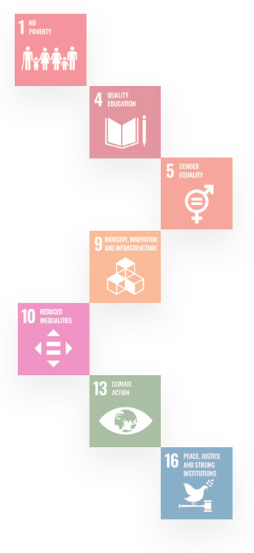Learning by doing and demonstrated through its holistic end to end stitch in model for circularity - alongside waste pickers, acknowledging them as integral contributors to the informal waste economy.

#### About Global Alliance for Waste Pickers

The International Alliance of Waste Pickers originated from the inaugural World Conference of Waste Pickers in 2008, uniting waste pickers' organizations and allies from 30+ countries. Annual meetings of the International Steering Committee guide our global vision, nurturing waste pickers' organizations globally. Active in UNFCCC meetings since 2009, we advocate for fair climate change solutions with the support of GAIA. Currently, our focus is on information exchange and solidarity among waste pickers’ organizations globally, facilitated by WIEGO and contributions from leaders and allies worldwide.

#### About Karachi School of Business & Leadership

Karachi School of Business and Leadership (KSBL) has established a leading think tank titled 'Circular Plastic Institute (CPI)' to serve as interdisciplinary and collaborative platform of research and advocacy for public, private, and academic stakeholders to move towards a data-driven, zero-plastic waste future for Pakistan. CPI aims at bringing practitioners, academics, and relevant stakeholders from public, private, and non- profit sphere together to generate evidence and knowledge transfer in the circular economy with a focus on plastics, using several models of center-member and center-stakeholder partnership.

#### About WIEGO

Women in Informal Employment: Globalizing and Organizing (WIEGO) is a global network focused on empowering the working poor, especially women, in the informal economy to secure their livelihoods. We believe that all workers should have equal economic opportunities, rights, protection and voice. WIEGO promotes change by improving statistics and expanding knowledge on the informal economy, building networks and capacity among informal worker organizations and, jointly with the networks and organizations, influencing local, national and international policies.

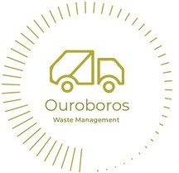

##### Milestone for Pakistan

The project findings and results were presented by the Ministry of Climate Change Delegation, at the International Alliance of Waste Pickers organized event on a ‘Just Transition’ at the INC-3 in Nairobi, Kenya in November 2023.

**Significance of the Project**

The informal waste sector is essential in promoting the circular economy, particularly in low and middle- income countries where waste pickers play a critical role in collecting and diverting waste to recycling markets. By reducing landfill usage and providing secondary materials, waste pickers make significant contributions to sustainable waste management. However, a lack of understanding regarding the organizational aspects and self-organization strategies employed by waste pickers hinders effective engagement with them.

This study aims to address this knowledge gap about waste pickers in Pakistan by utilizing a mixed- methods approach and a review of recent literature. The research involved conducting key informant interviews, surveys, and qualitative interviews in three cities.

###### Authors



**Peer Review**

**Ali Syed** Circularity Expert/ Founder Ouroboros WM

**Shiza Aslam** Circular Economy Expert Karachi School of Business

**Dr. Mansoor Ali** Waste Management Consultant Ouroboros WM

The findings reveal various coping mechanisms developed by waste pickers to navigate financial uncertainties, and family involvement and kinship- based connections emerged as significant factors influencing their entry and smooth working.

Waste pickers are autonomous self-employed workers with entrepreneurial skills, which provide a deep understanding of the economics and business aspects of waste management. Self-organization, often based on trust and mutual understanding, played a crucial role in waste pickers' daily operations.

Kabir Arora - Global Alliance of Waste Pickers Dr Safdar Sohail - Social Protection Resource Centre (SPRC)

Dr Zaigham Abbas - Ministry of Climate Change

###### Commissioning and Support

This project was conducted by Ouroboros Waste Management (OWM) in collaboration with the Karachi School of Business & Leadership, commissioned by the International Alliance of Waste Pickers and Women in Informal Employment Globalizing and Organizing (WIEGO).

##### Way Forward

Key next steps, are primarily focused on achieving the goal of ‘ending plastic pollution’, ‘whilst facilitating a just transition’. Collaborative engagement with other countries in the Asia Pacific Region is also identified as a critical component of achieving this goal.

While the approach and methods for achieving this goal are still under design, adopting a human-centered approach to decision-making and growth is a fundamental prerequisite for progress.

** (WIEGO) and Undertaken by Ouroboros Waste Management (OWM) supported by Karachi School of Business & Leadership (KSBL)



One key aspect that requires immediate attention is the protection of waste pickers, particularly in regions where waste cooperatives and unions may be absent, as is the case in Pakistan.

The challenges faced by waste pickers in such contexts are likely shared by many other countries.

Therefore, a collaborative effort will be initiated to explore effective measures and mechanisms to safeguard the rights and well-being of waste pickers, ensuring their inclusion in the transition process.

This collective endeavor will involve research, knowledge exchange, and the development of practical strategies to address the unique challenges faced by waste pickers in the absence of formal organizational structures.

Through this inclusive and collaborative approach, we aim to pave the way for sustainable and equitable solutions in the global fight against plastic pollution.

##### Ouroboros Waste Management Karachi School Business & Leadership

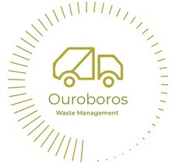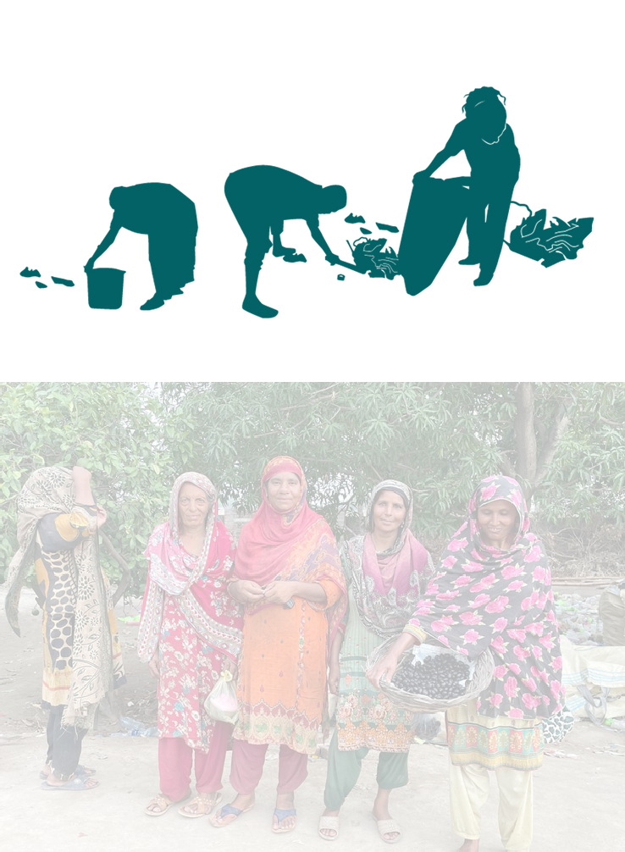

***Ouroboros Waste Management***

**https://ouroboros.com.pk |** [**info@ouroboros.com.pk**](mailto:info@ouroboros.com.pk)